

DXC RealTime Projects

AZ-900, DP - 203



June 10, 2022

DXC Technology

Name: Shan

Reg No: DXC262AB1228

**Project1 Name: Smart Vehicles**

Date: 10TH June 2022

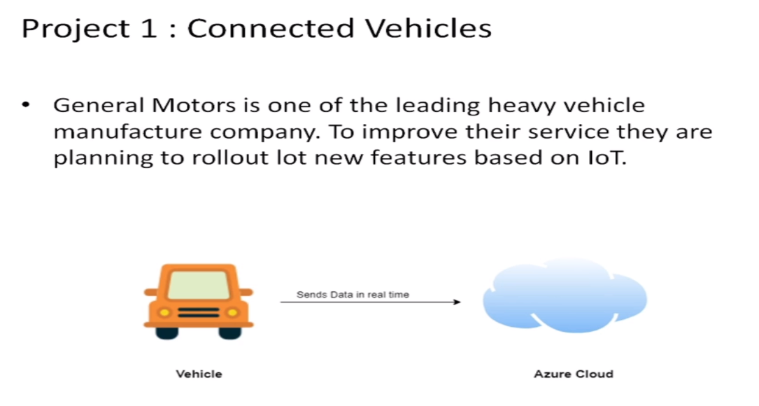

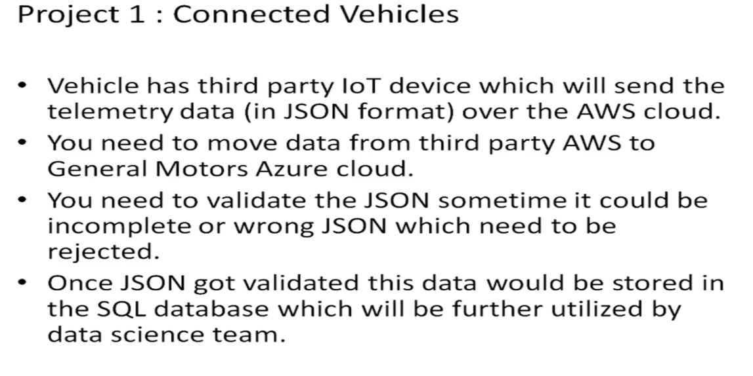

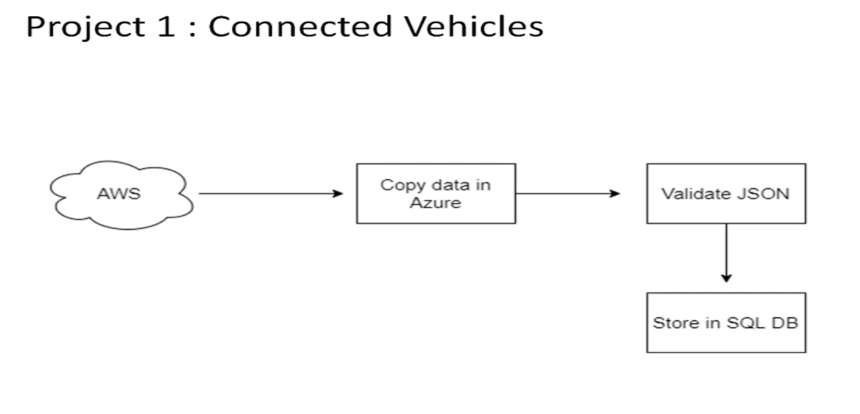

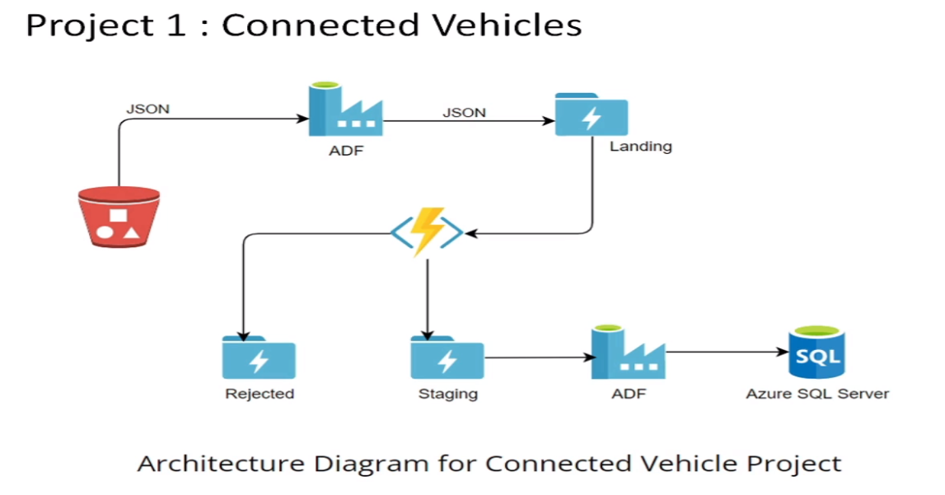

Practical Lab: Create **Azure Data Factory** Account for Data pipelines.

STEPS TO CREATE AZURE DATA FACTORY ACCOUNT FOR DATA PIPELINES.

STEP 1:-CLICK ON SEARCH MENU THEN CLICK ON DATA FACTORY.

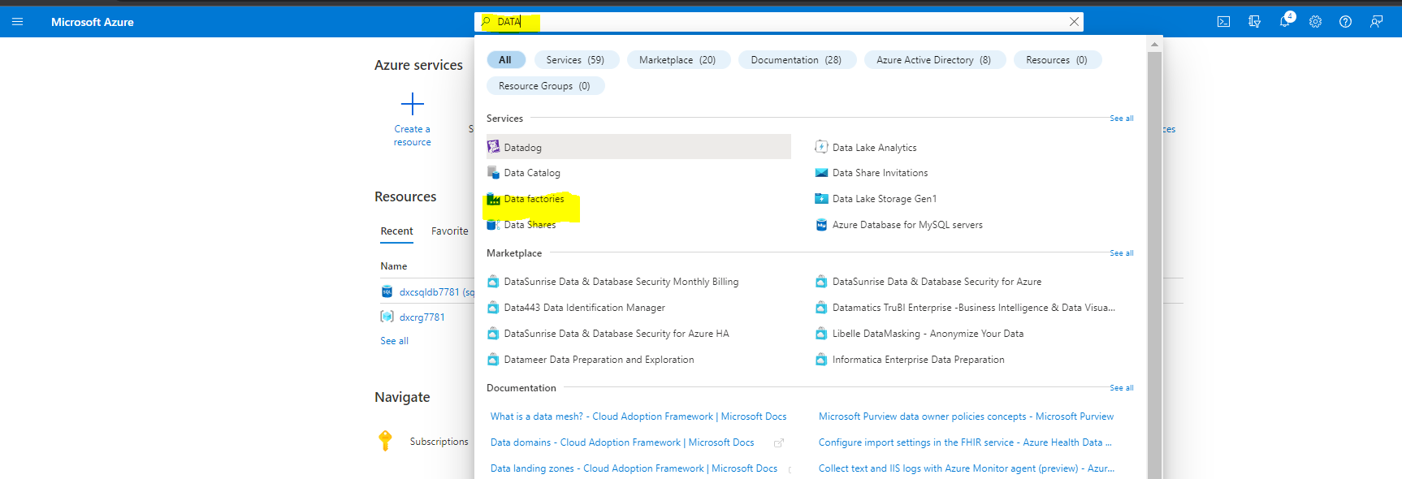

STEP 2:-CLICK ON CREATE.

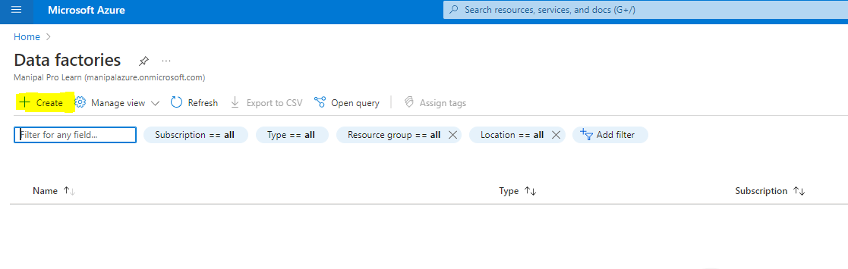

STEP 3:-FILL ALL THE PROJECT DETAILS AND CLICK ON NEXT.

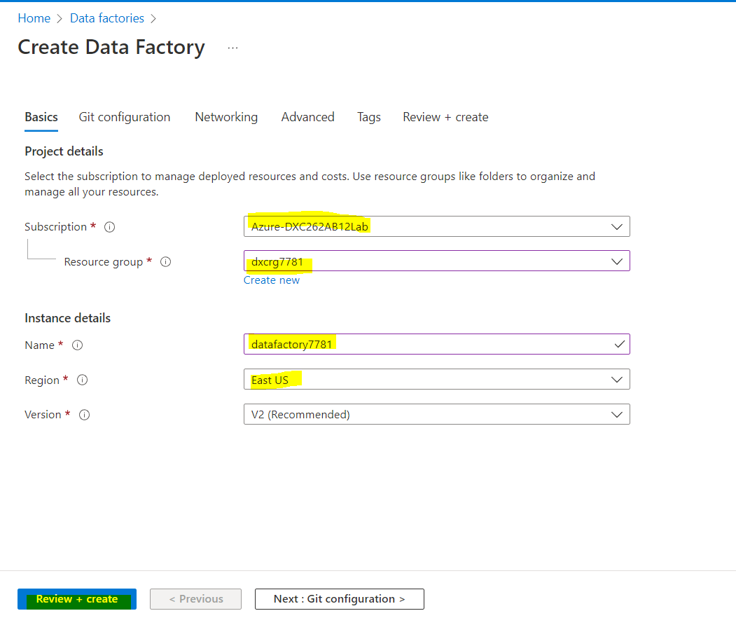

STEP 4:-TICK ON THE BOX TO CONFIGURE GIT LATER.

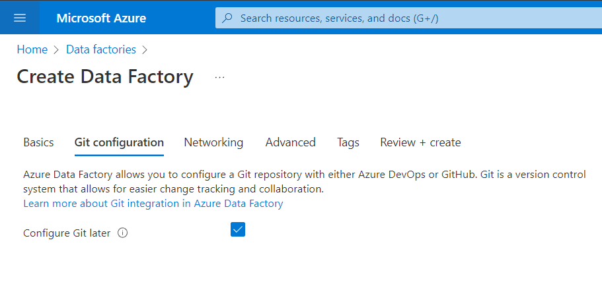

STEP 5:- AFTER THE VALIDATION IS PASSED CLICK ON CREATE.

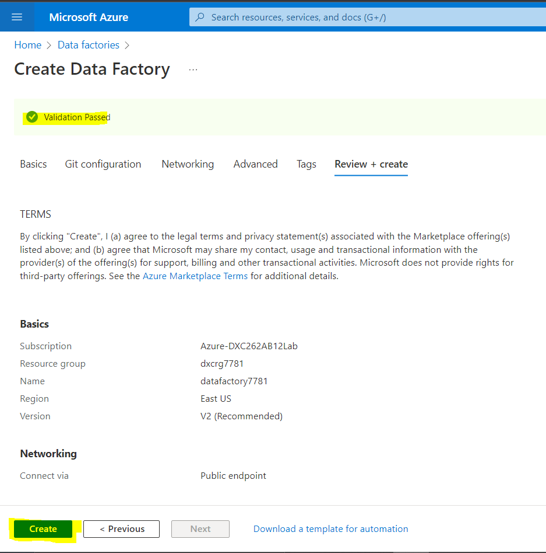

STEP 6:-AFTER THE DEPLOYMENT IS COMPLETE CLICK ON GO TO RESOURCE.

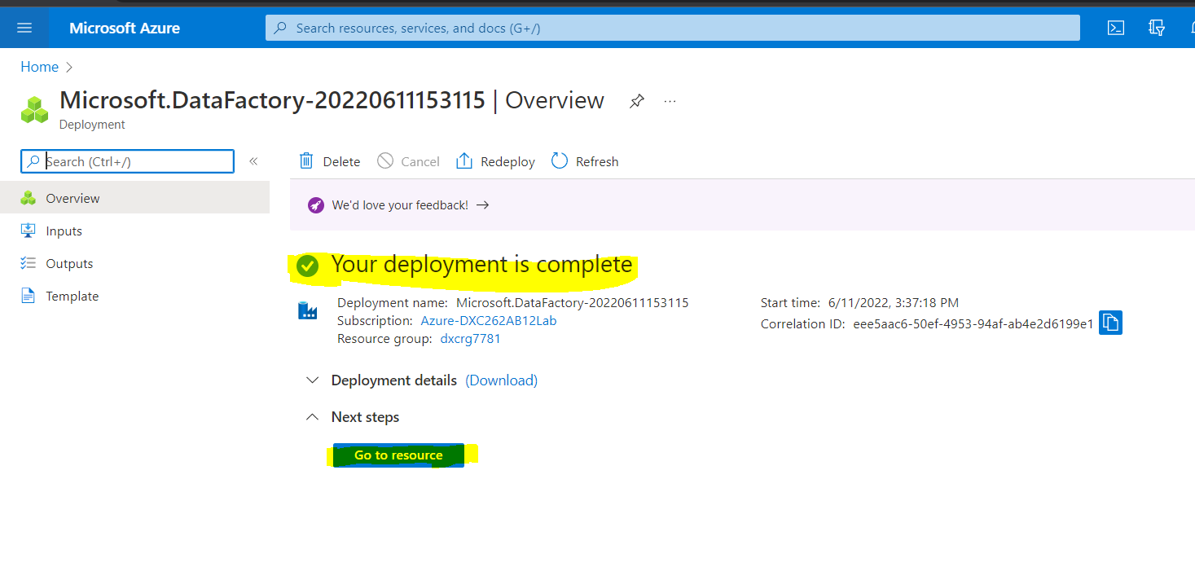

STEP 7:- CLICK ON OPEN AZURE DATA FACTORY STUDIO.

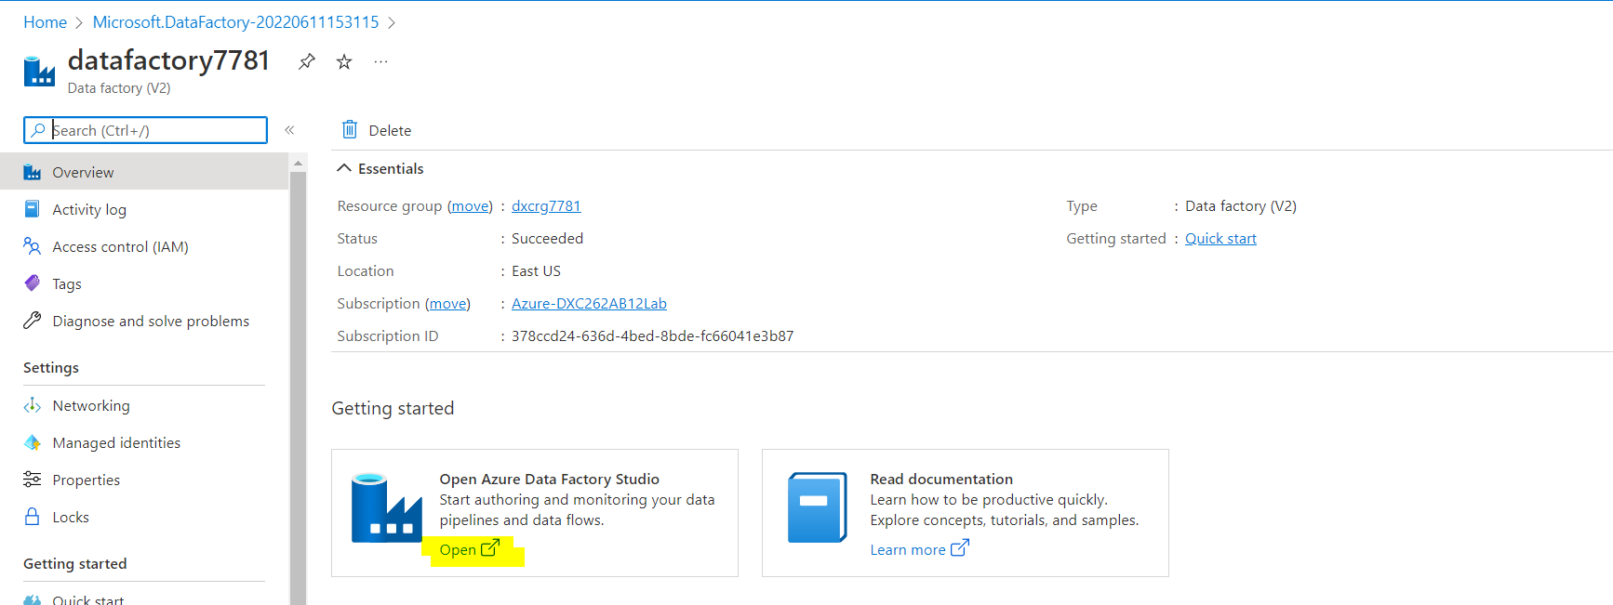

STEP 8:- AZURE DATA FACTORY IS OPEN IN NEW TAB.

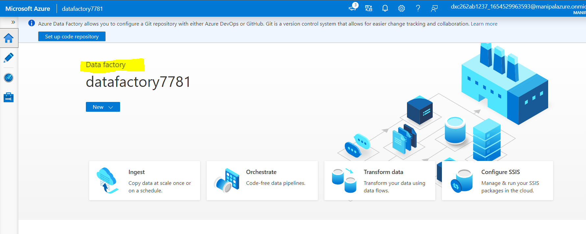

Practical Lab: Create **ADF Pipeline** End to end pipeline with triggers enabled.

Practical Lab: Create **Azure blob trigger** logic.

Step 1:-Go to Azure, search for storage. Click on Storage Account. Click on + Create.

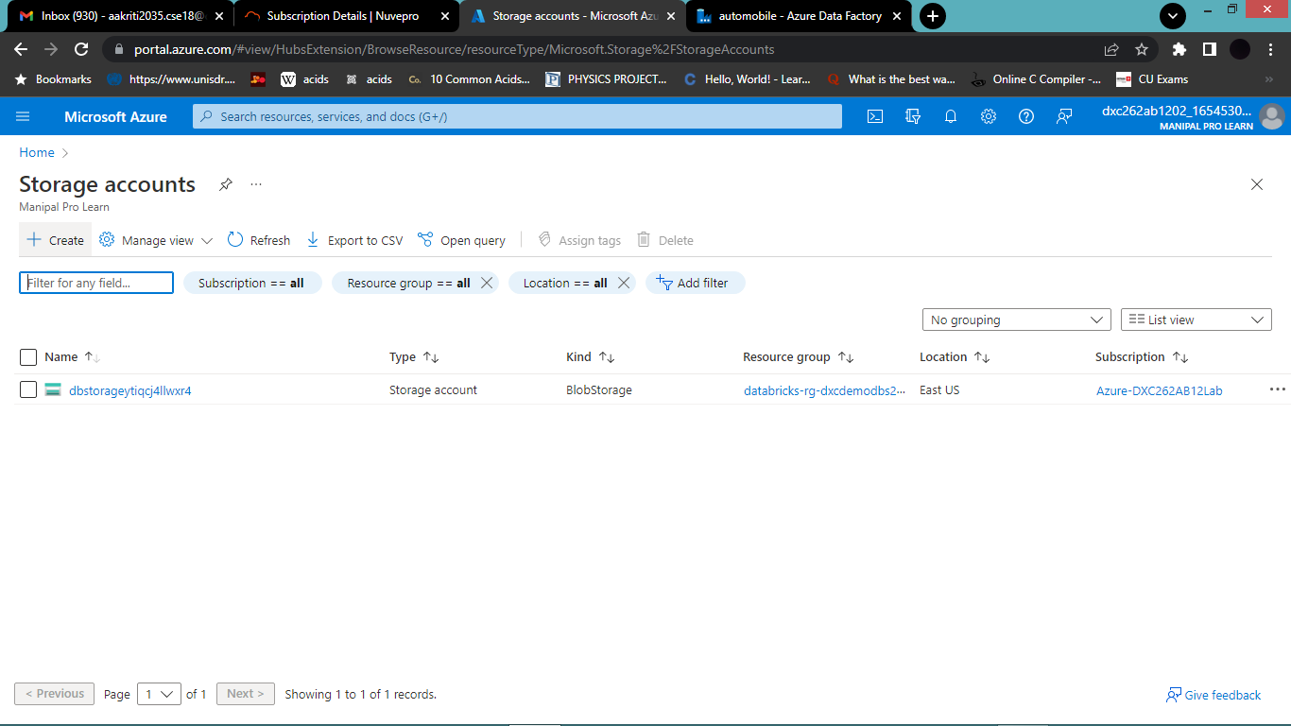

Step 2:-Fill up all the details and click on Review+Create. Deploy it .

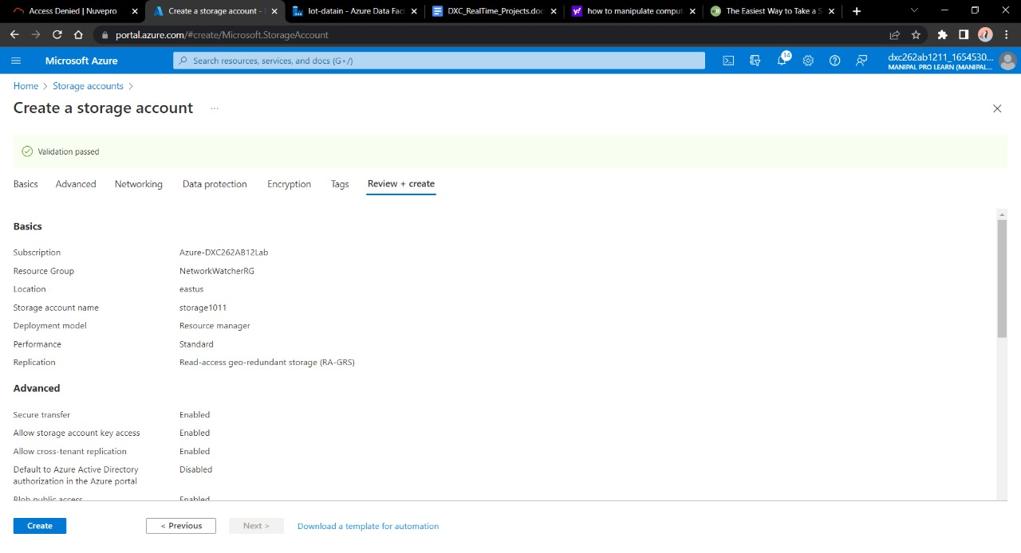

Step 3:-Once deployment is done click on Resource Group.

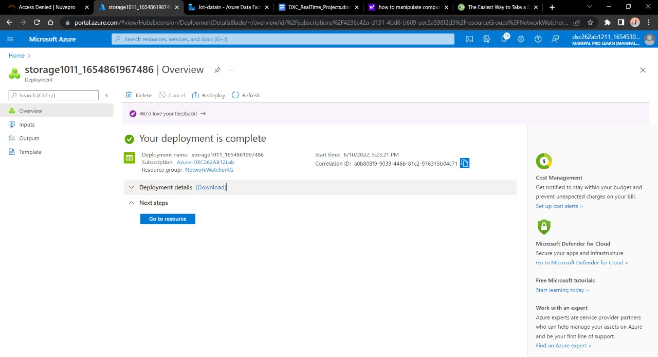

Step 4:-Navigate towards containers. Click on *+ Container*.

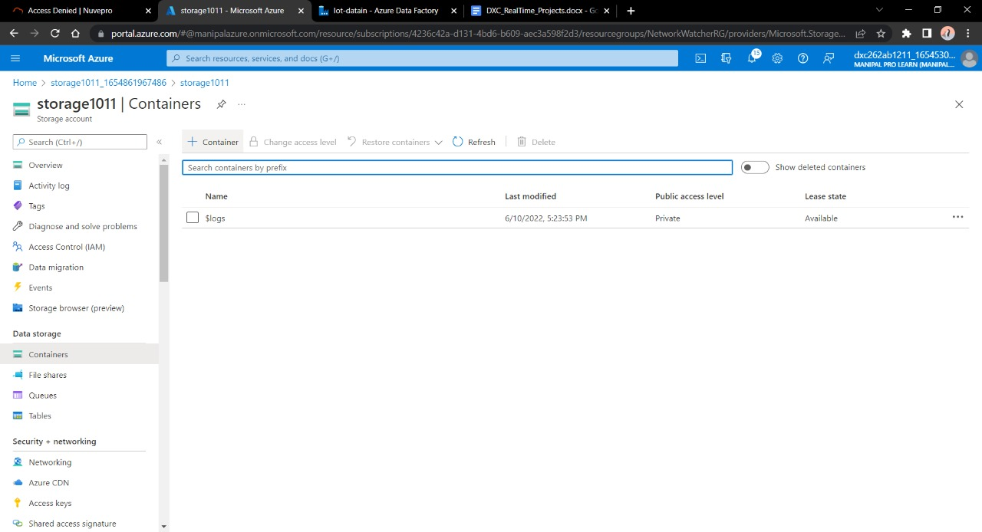

Step 5:-Container is used in order to store the data. Click create.

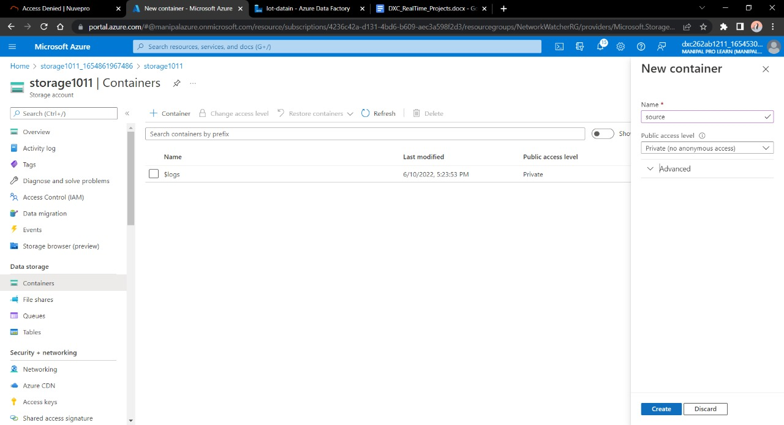

Step 6:-Give a name to the container Click on upload.

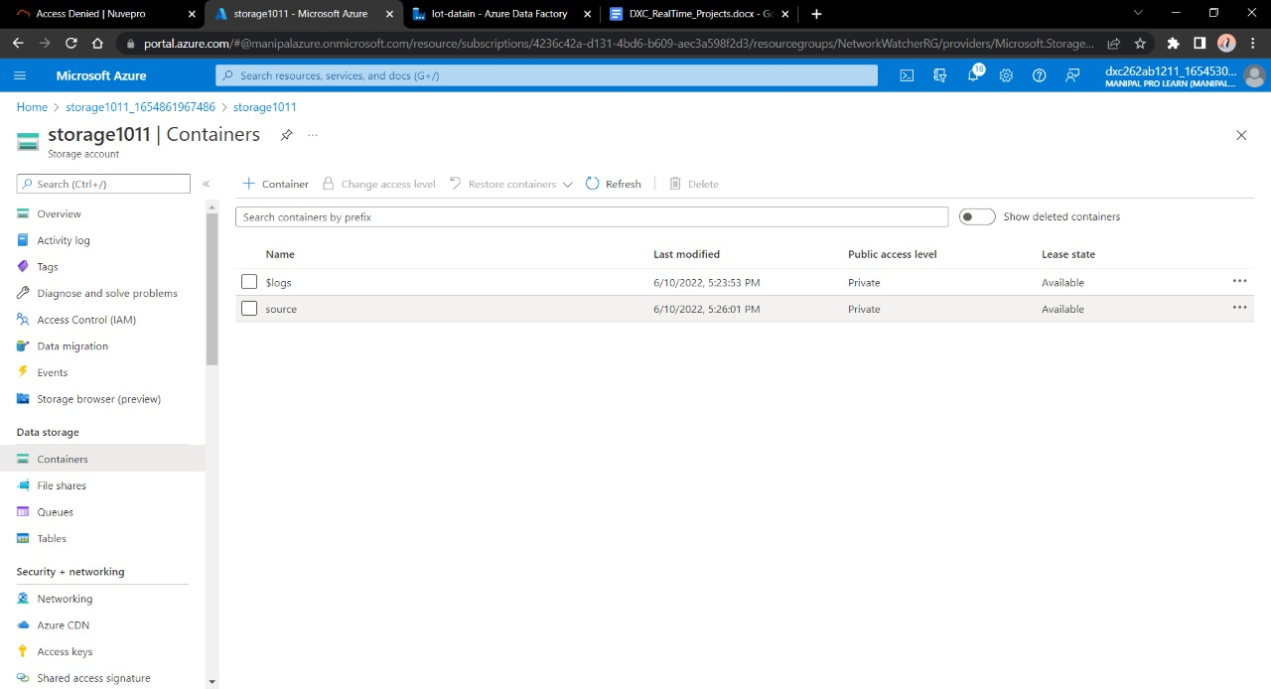

Step 7:-Considering we don’t have the source of the data we will make this container as the source of our blob data and will fill in a sample file to paste into the sql database.

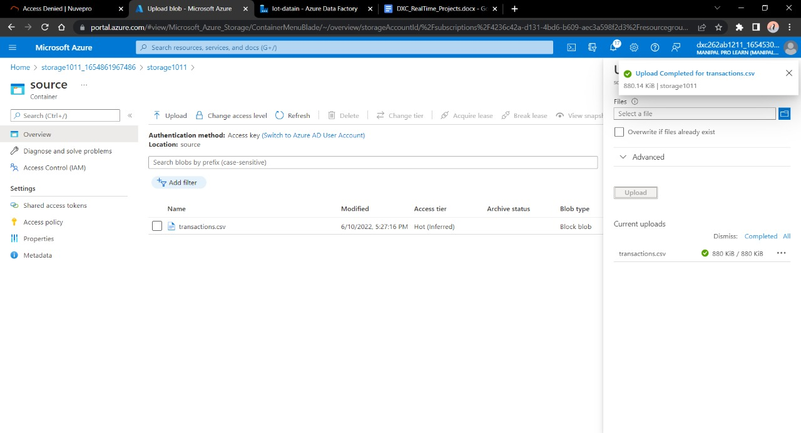

Practical Lab: Create Azure **SQL Server and Database**

STEPS TO CREATE SQL SERVER. AND DATABASES.

STEP 1: - CLICK ON SEARCH THEN SEARCH FOR SQL DATABASES.

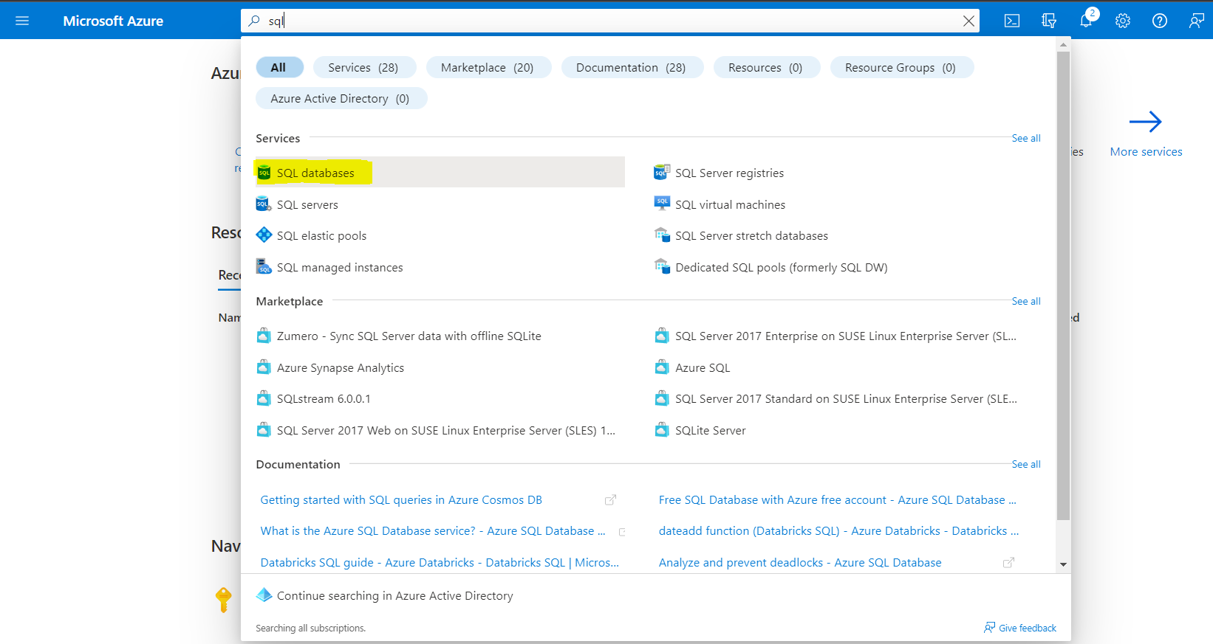

STEP 2:-CLICK ON CREATE.

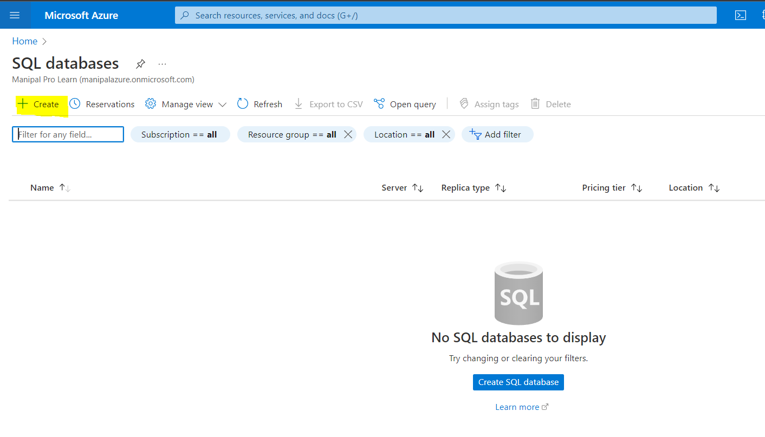

Step 3:-FILL ALL THE PROJECT DETAILS.

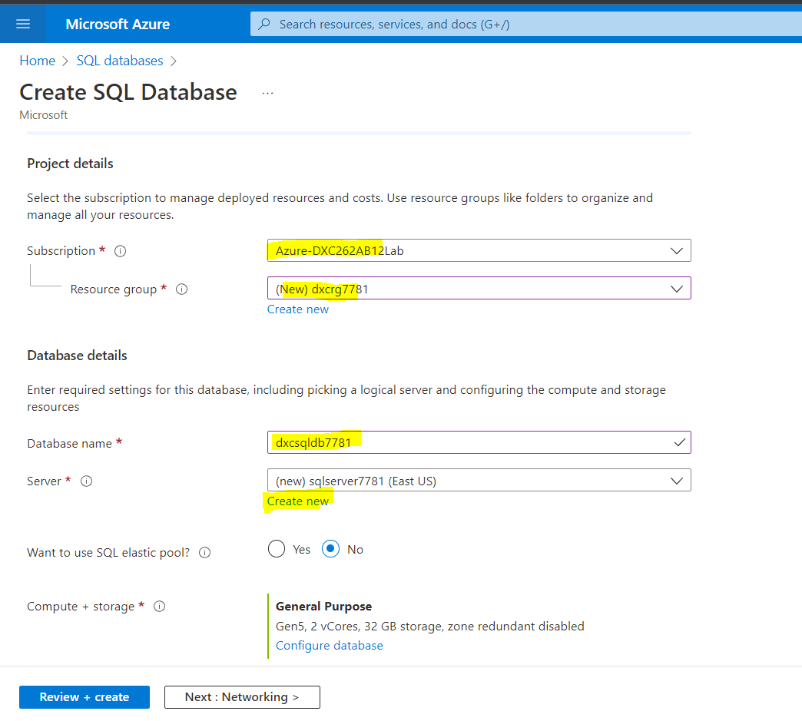

STEP 4:-CLICK ON CREATE NEW SQL DATABASE SERVER.

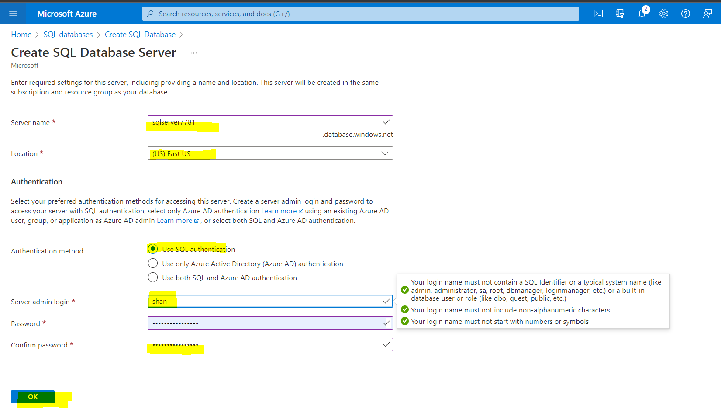

STEP 5:-CLICK ON CONFIGURE DATABASE IN COMPUTE+STORAGE AND SELECT THE SERVICE TIER COMPUTE TIER TO SERVERLESS.

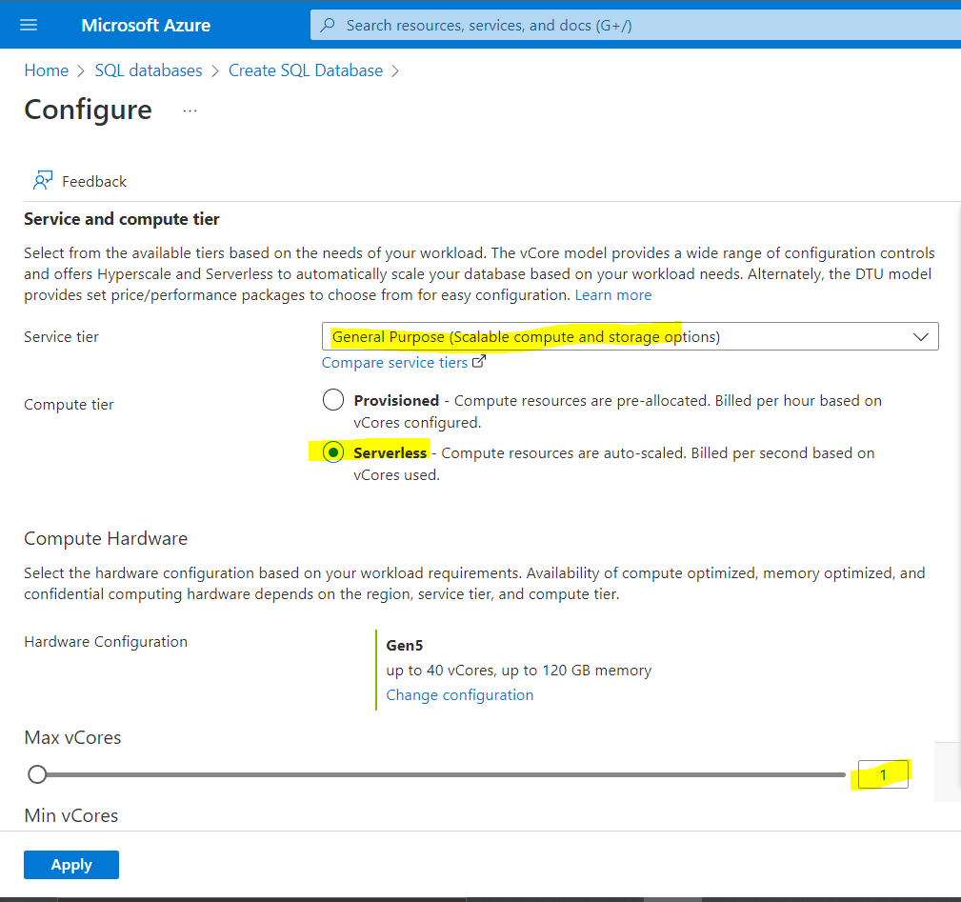

STEP 6:-CHOOSE MAX AND MIN CORES AND THEN CLICK ON APPLY.

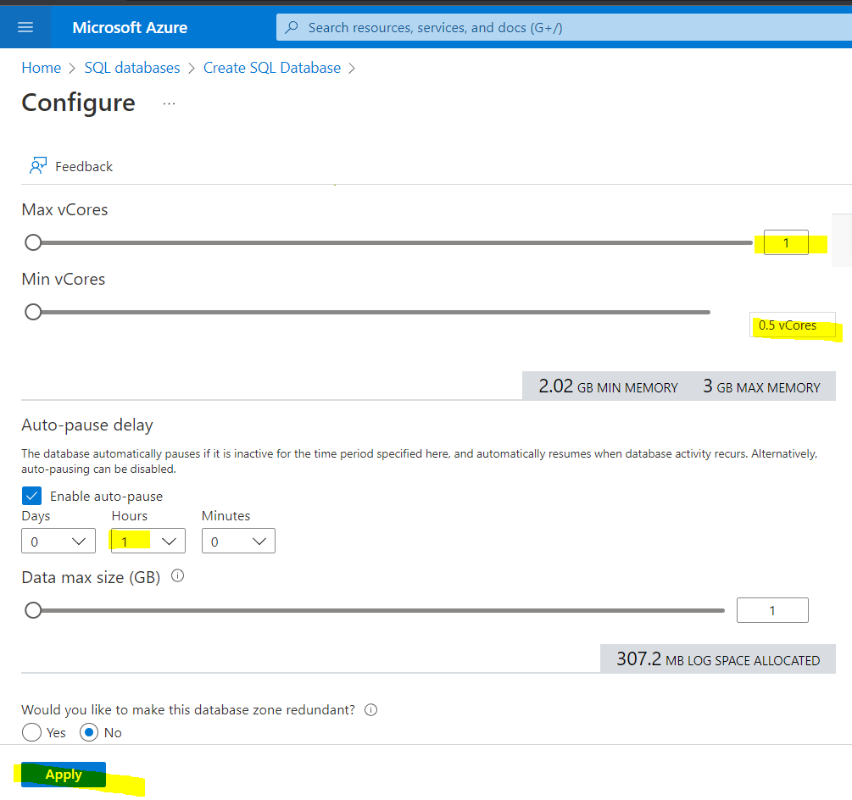

STEP 7:- NOW CLICK ON REVIEW AND CREATE.

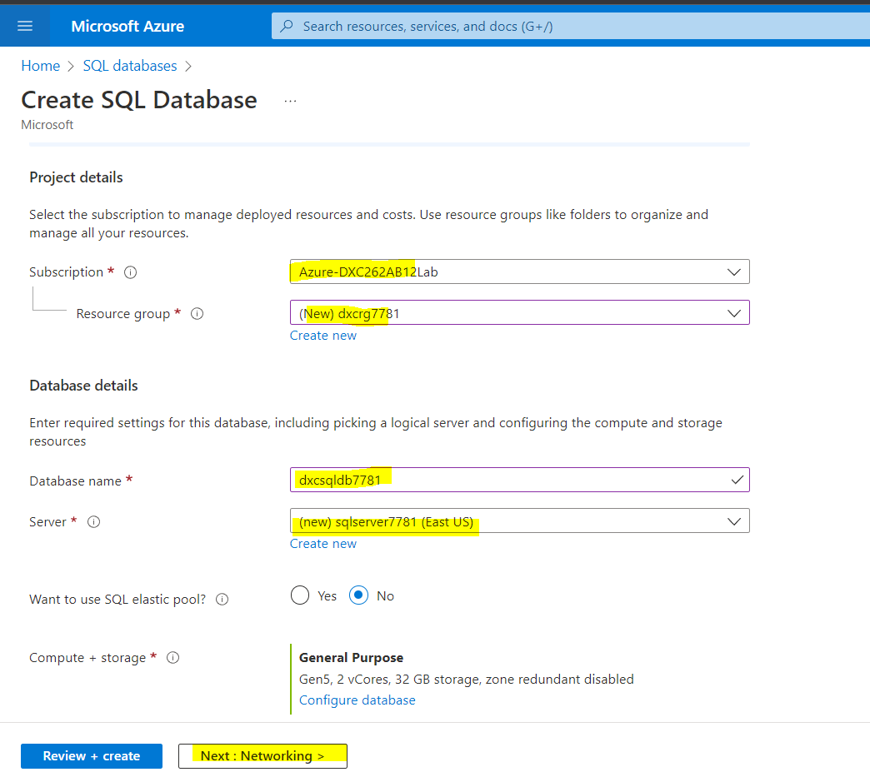

STEP 8: - NOW CLICK ON CREATE AND THEN SQL DATABASE WILL BE CREATED.

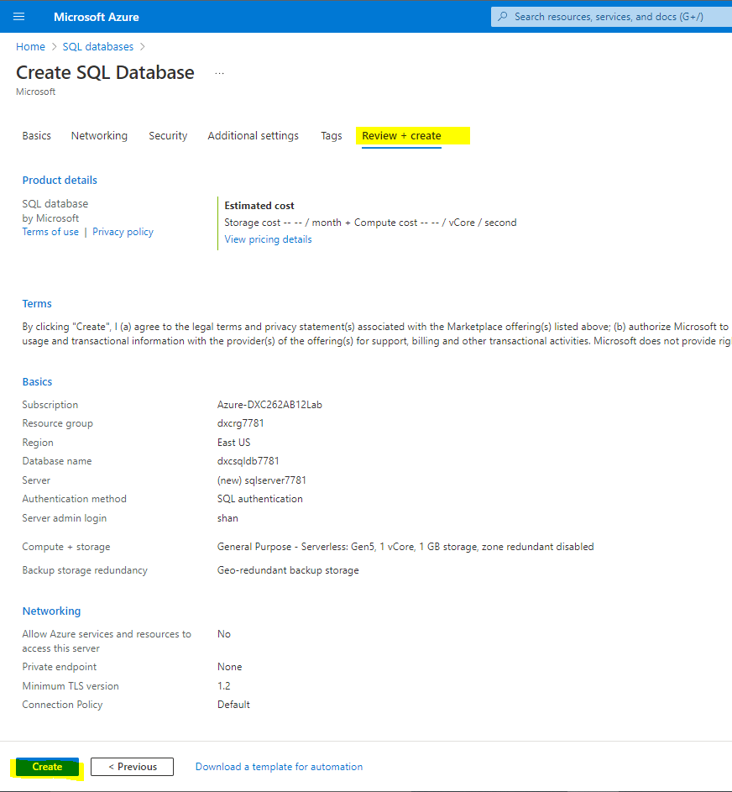

STEP 9:-WHEN THE DEPLOYEMENT IS COMPLETED.THEN CLICK ON GO TO RESOURCE.

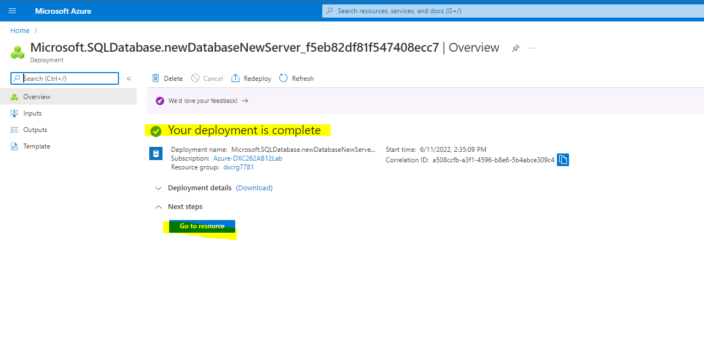

STEP 10:-CLICK ON QUERY EDITOR THEN GIVE YOUR LOGIN CREDENTIALS AND THEN CLICK ON OK.

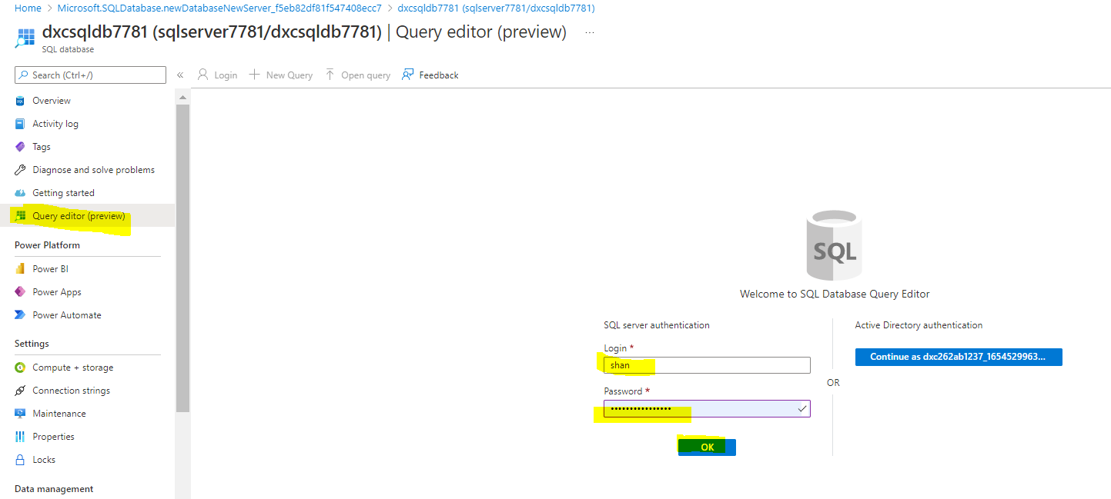

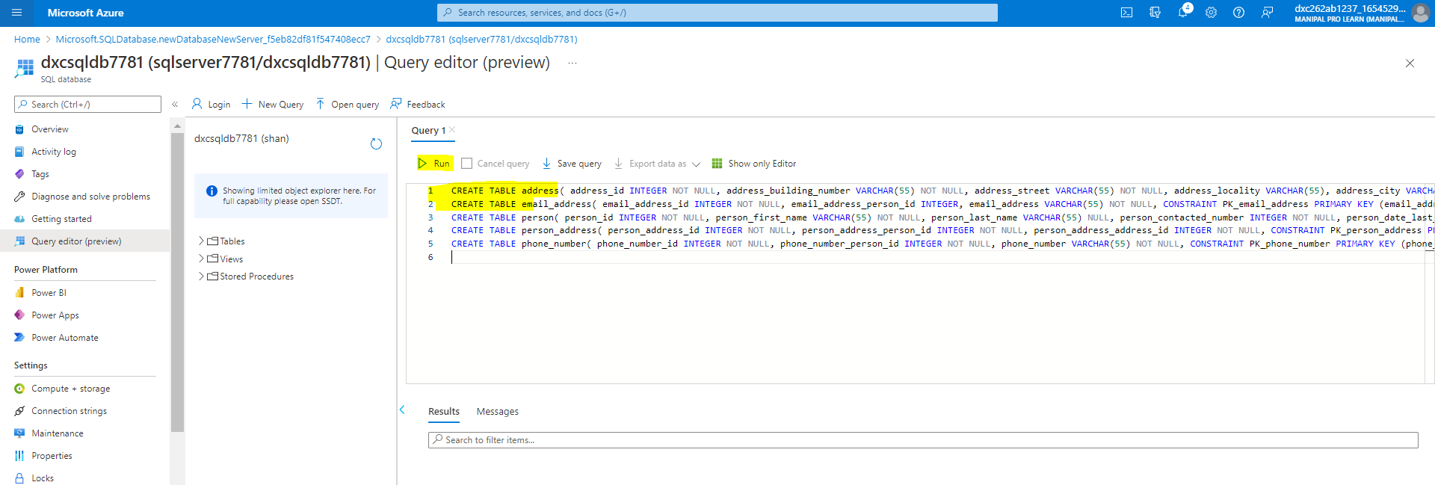

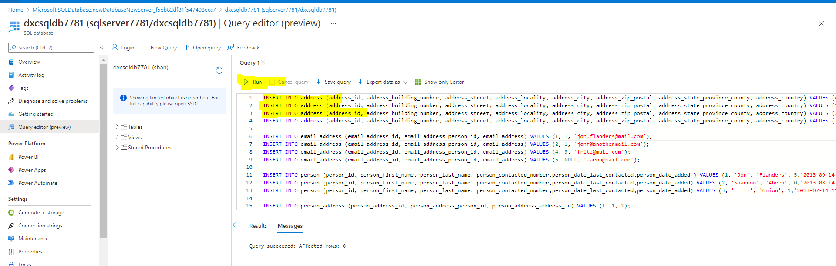

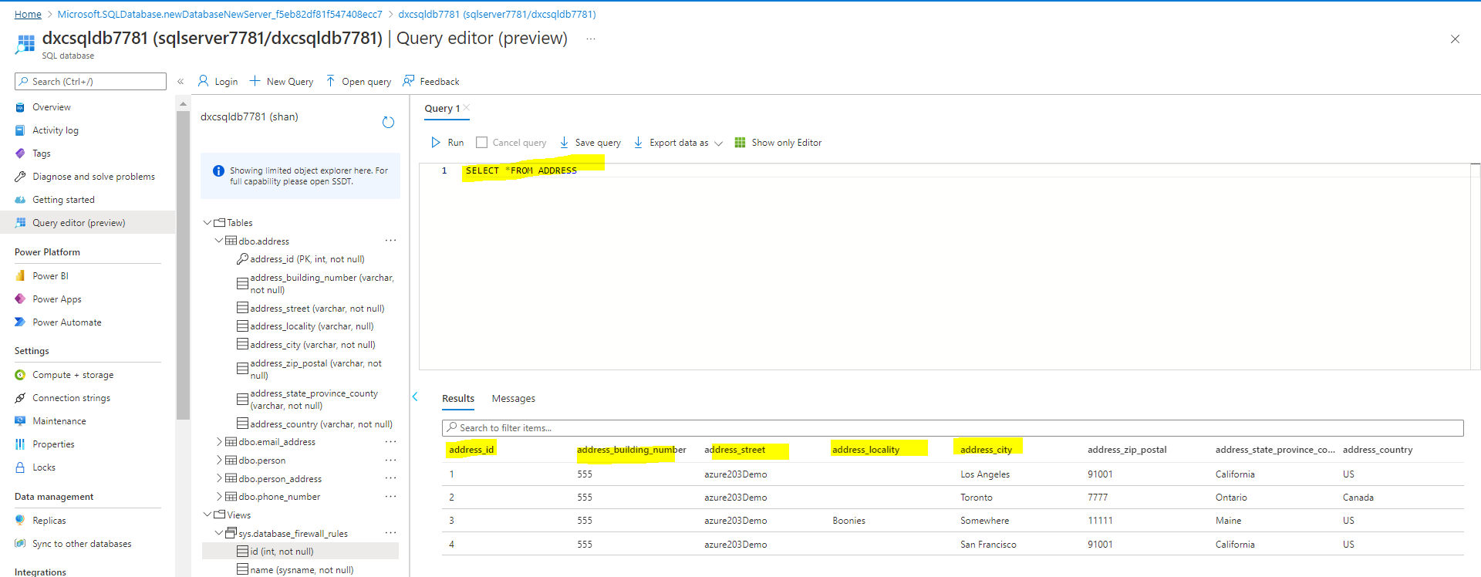

Practical Lab: Add another STEP pipelines for moving data from Staging to **SQL DB**

After these steps come back to **Azure Data Factory Lab .** Here we need to create a pipeline that will take data from blob storage and feed into the SQL database.

Step 1:- Click on ingest.

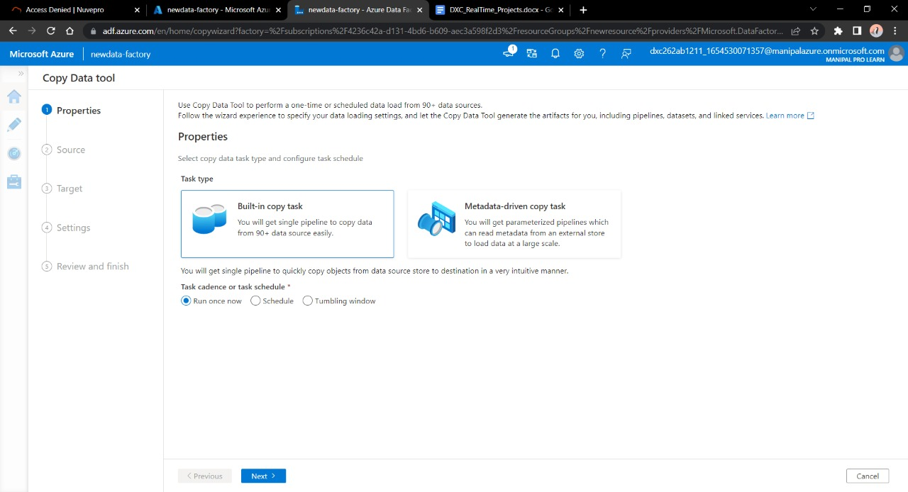

STEP 2:- Enter the name of Azure blob storage linked file. Select the name of storage account name we created in this and click on Create.

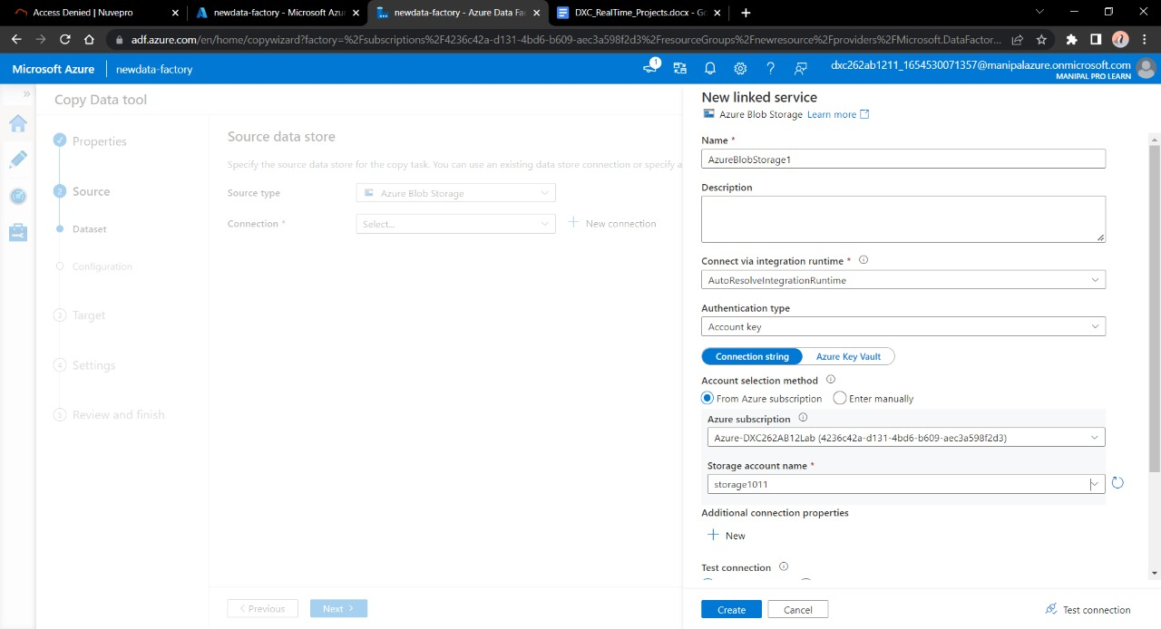

Step 3:- Select the source type as blob storage and connection name that we created in previous step. Click Recursively from Options. Click Next.

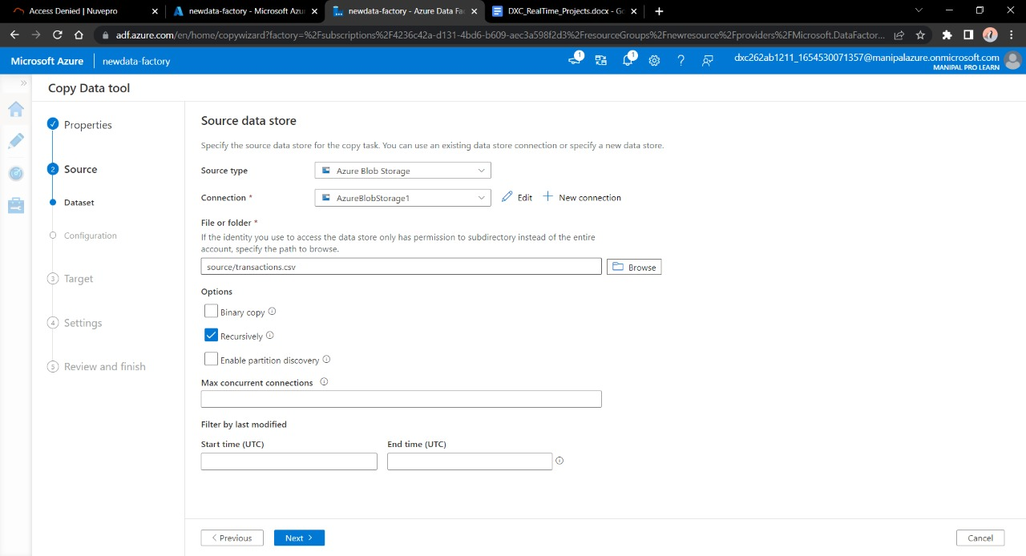

Step 4:- Choose the output format of the data

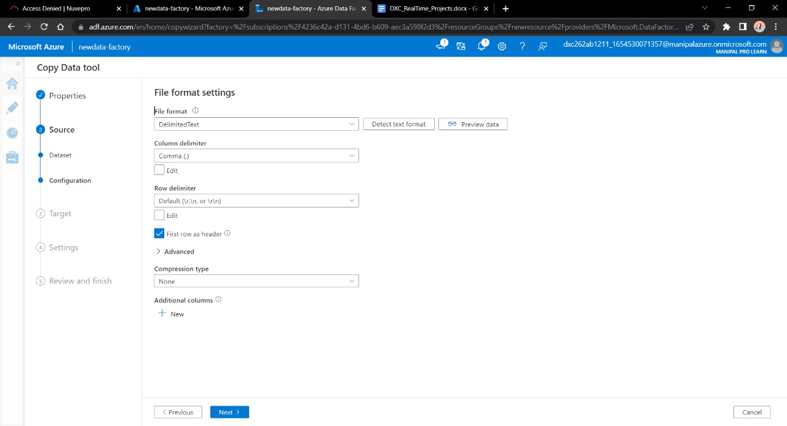

Step 5:-Now, in the next step we will link the Data Factory with SQL database. Connect the database with new connection.

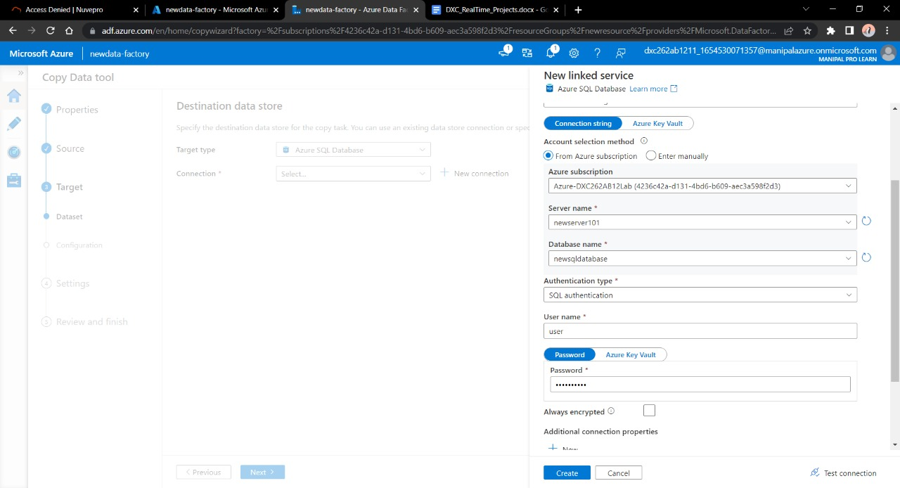

Step 6:-Choose the file name you want to see in the SQL database. Click Next.

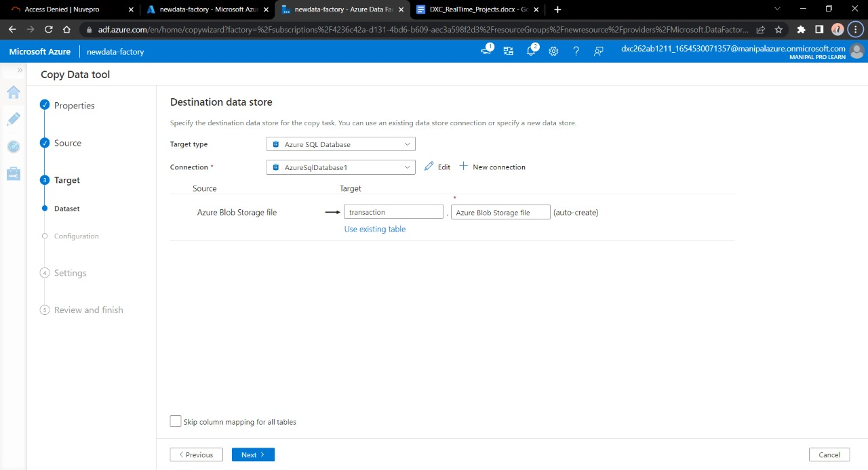

Step 7:- Now we are the end stage of creating pipeline, click next.

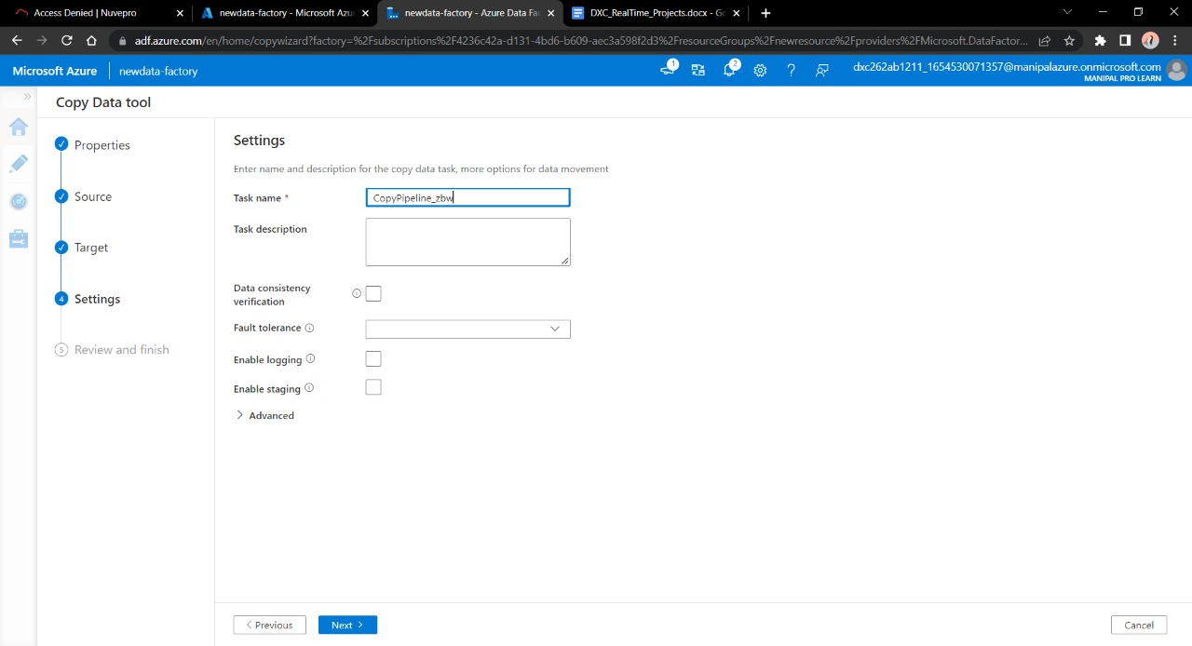

Step 8:-Validate the data, connection, details and move forwards with Next

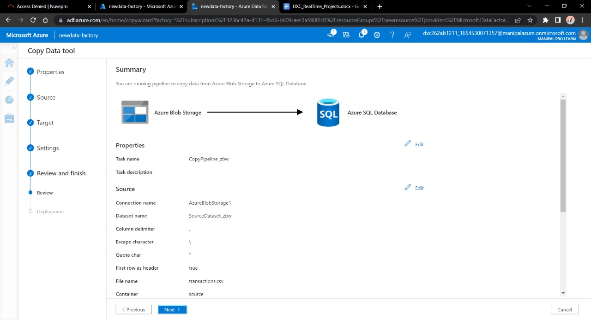

Step 9:-Trigger the pipeline manually and navigate towards monitor, Here we can see our pipeline has successfully ran once.

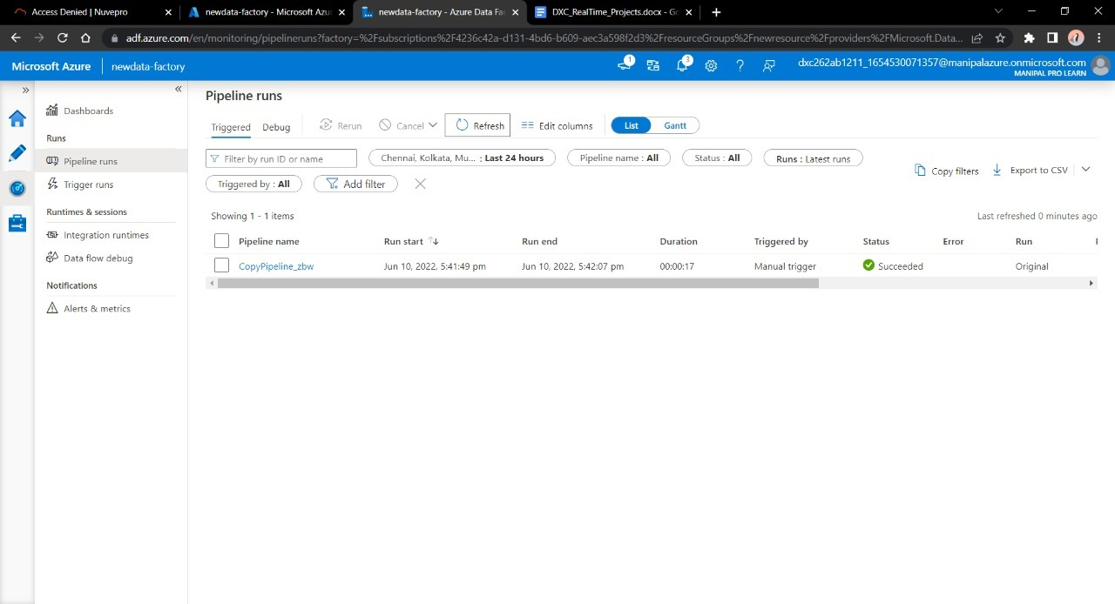

Step 10:-Navigate towards SQL database in order to check the data.

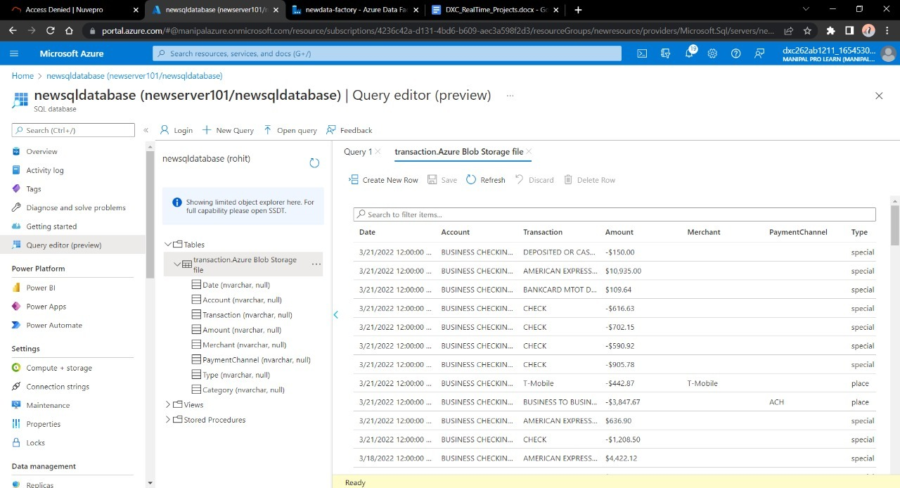

**Result:** In this project we were successful in creating a pipeline that will validate and copy the blob data into the SQL database using Azure Data Factory

**Conclusion:** The Blob data is being successfully validated and stored into SQL database.

Name: SHAN

Reg No: DXC262AB1228

**Project2 Name: AP Morgan Data Platform**

Date:10TH JUNE 2022

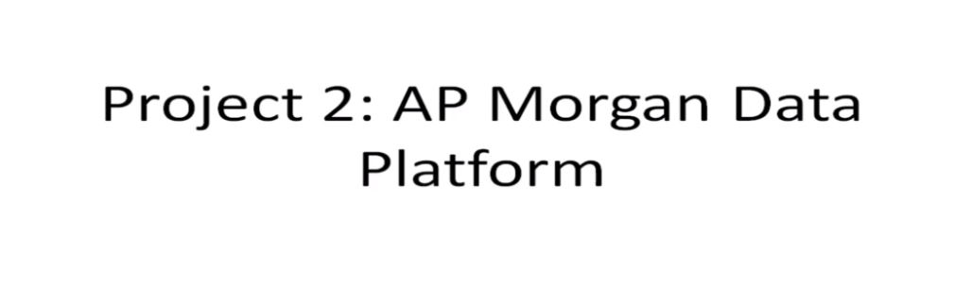

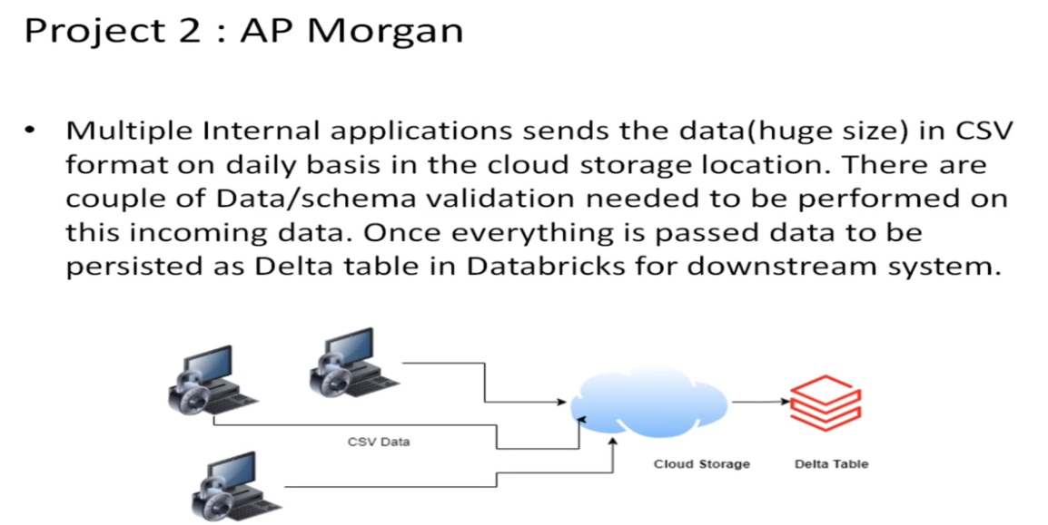

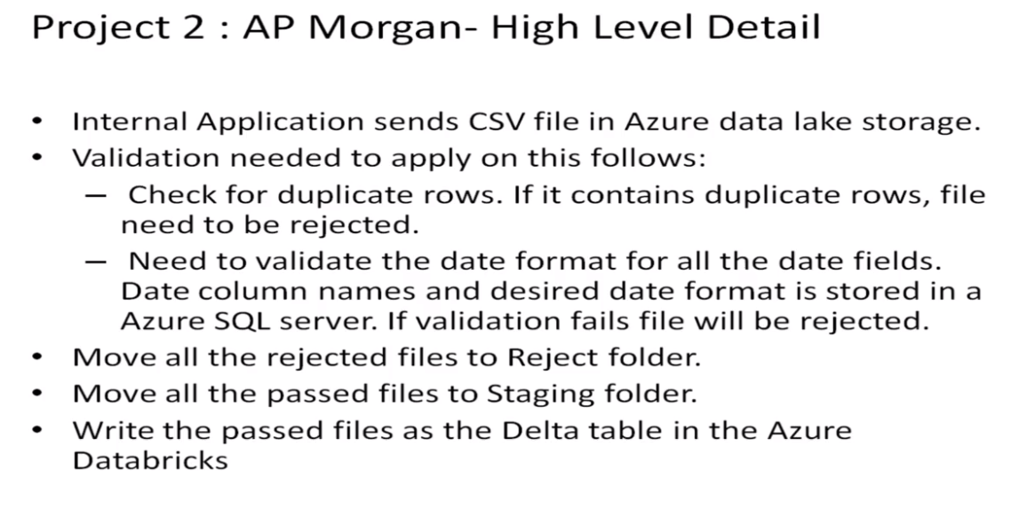

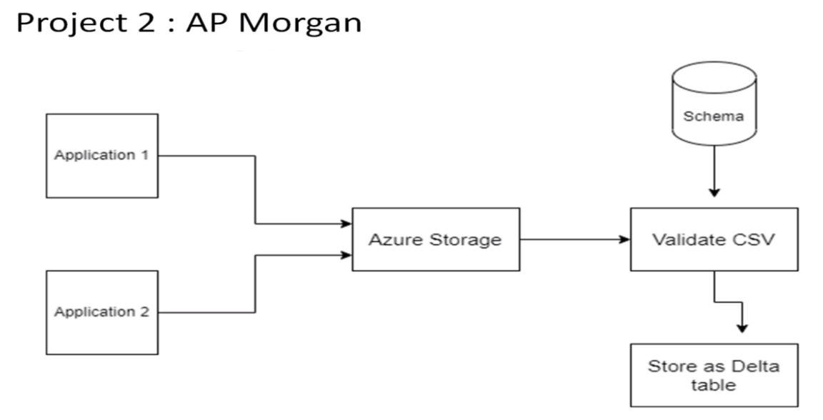

Practical Lab: Create a **Databricks**

STEPS TO CREATE DATABRICKS:-

FIRST WE NEED TO OPEN MICROSOFT AZURE PORTAL THEN INSIDE THE PORTAL WE NEED TO FOLLOW THESE STEPS

STEP 1:- SEARCH FOR DATABRICKS IN THE SEARCH AREA AND CLICK ON IT.

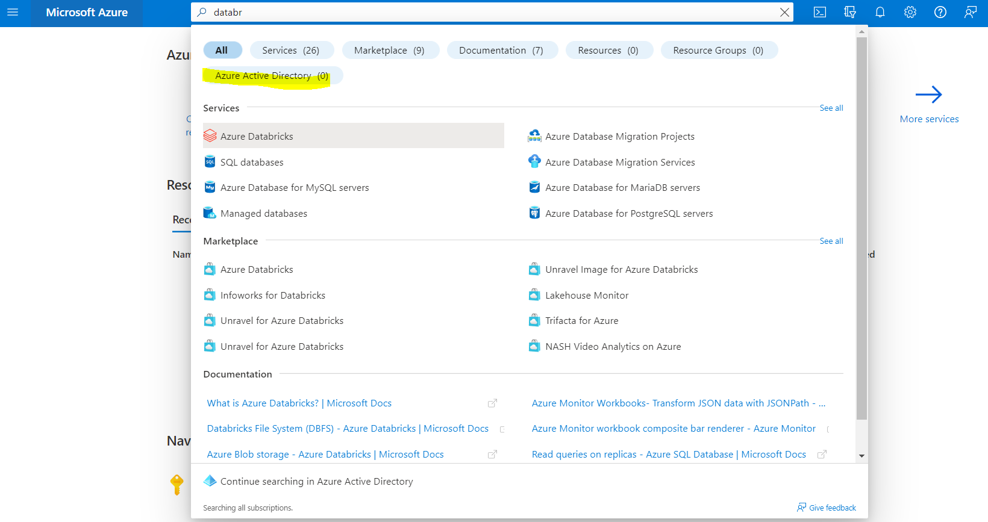

STEP 2:- CLICK ON CREATE.

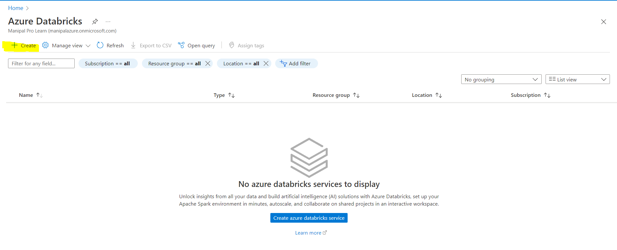

STEP 3:- IN CREATE AN AZURE DATABRICKS WORKSPACE FILL ALL THE PROJECT DETAILS AND CLICK NEXT.

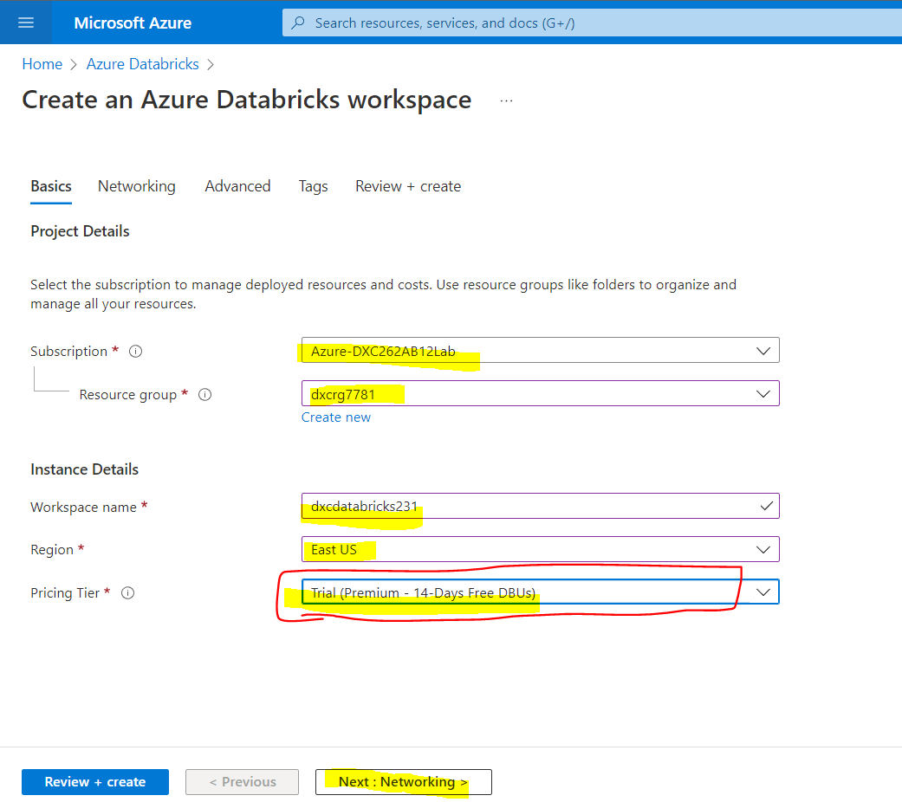

STEP 4:- SKIP NETWORKING, ADVANCED, TAG AND THEN CLICK ON REVIEW+CREATE AND AFTER THE VALIDATION IS SUCCEEDED. CLICK ON CREATE.

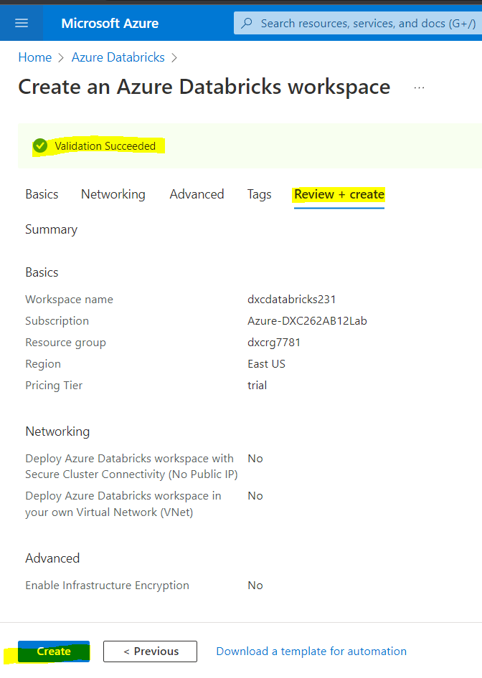

ATER DEPLOYMENT IS DONE THEN GO TO RESOURCES.

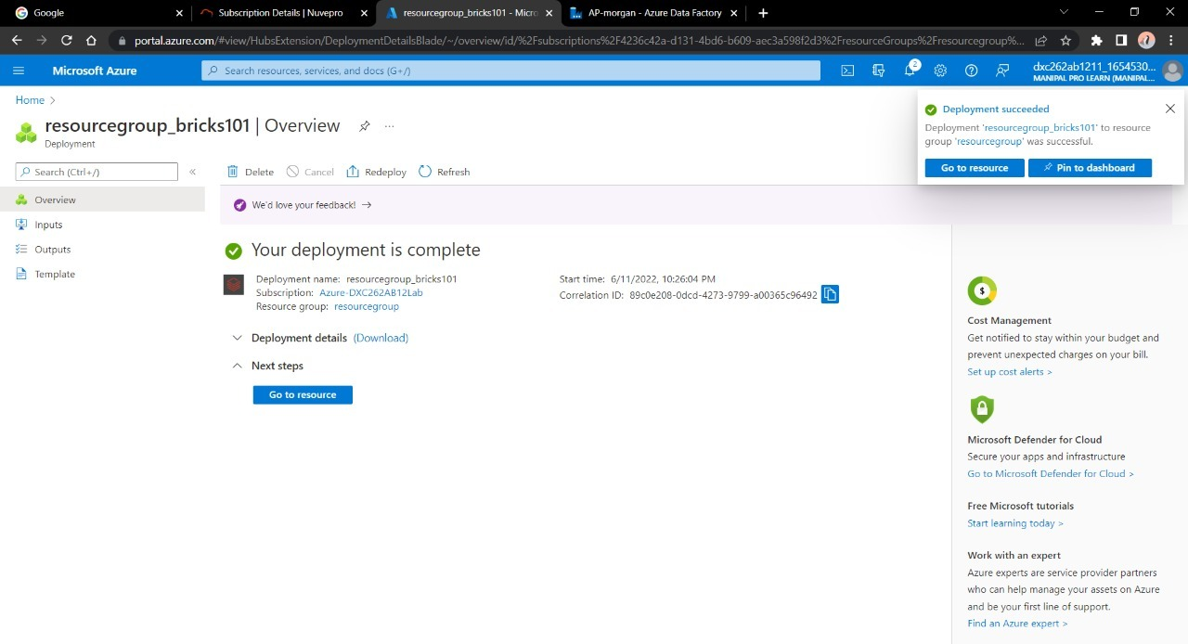

STEP 5:- AFTER CREATING CLICK ON LAUNCH WORKSPACE.

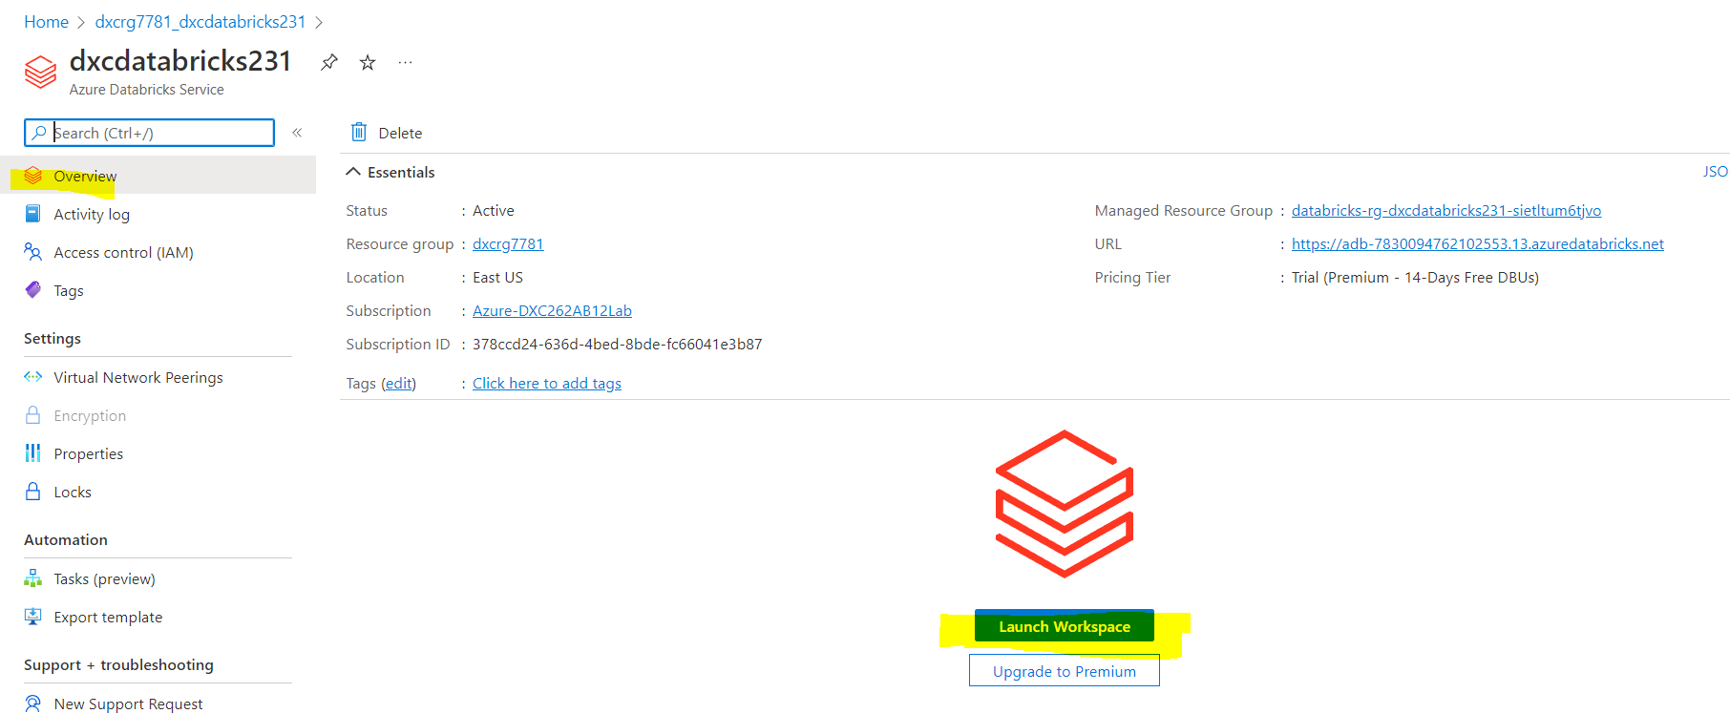

STEP 6:-AFTER CLICKING ON LAUNCH WORKSPACE, DATABRICKS WILL OPEN IN NEW TAB.

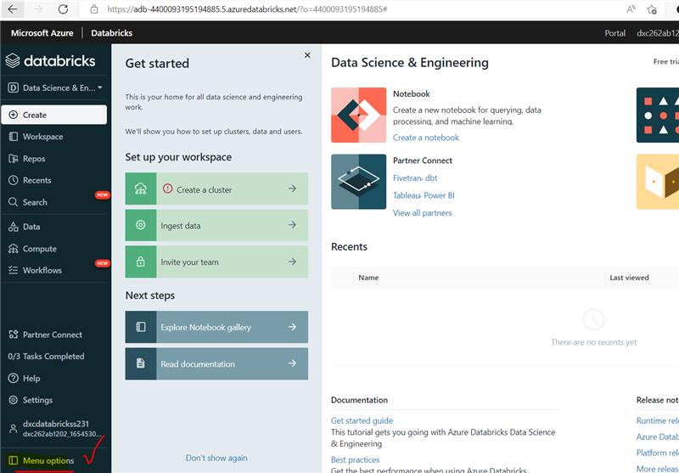

Practical Lab: Create **Cluster in Azure Databricks**

STEPS TO CREATE CLUSTER IN AZURE DATABRICKS:-

STEP 1:- IN DATABRICK CLICK ON COMPUTE.

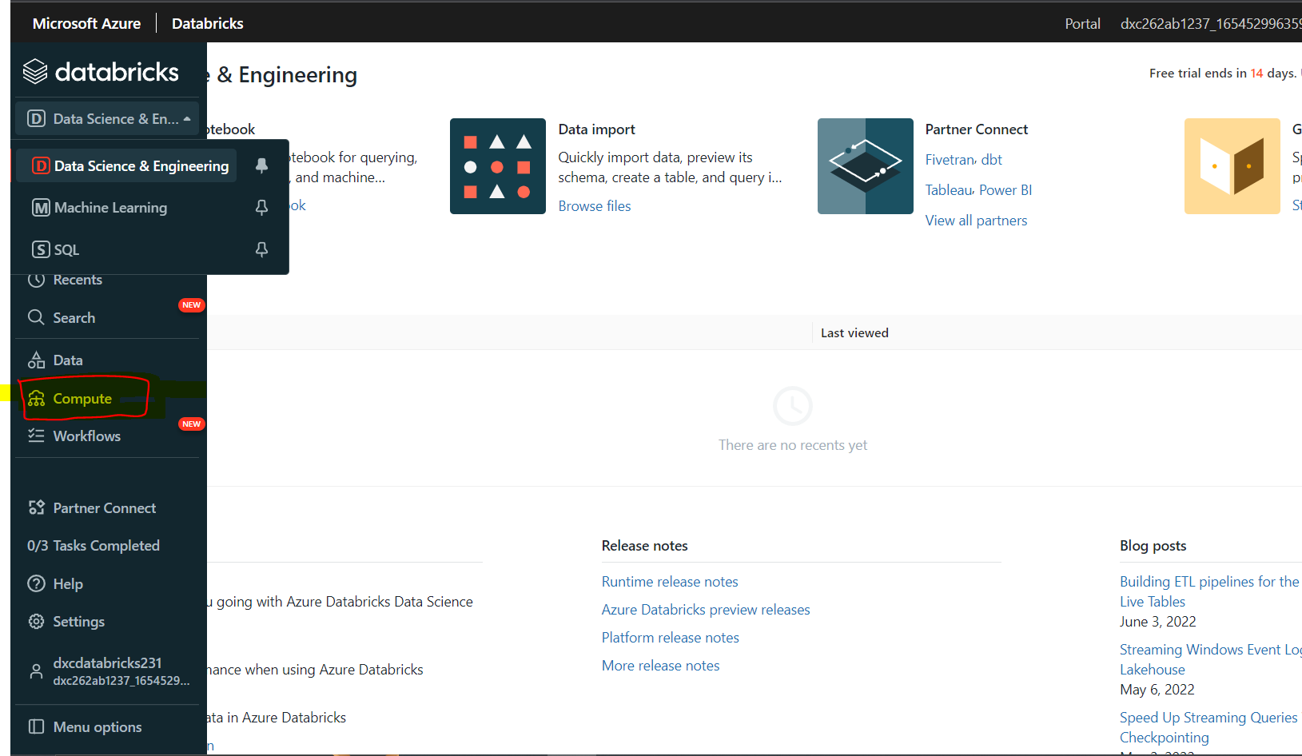

STEP 2:-CLICK ON CREATE CLUSTER.

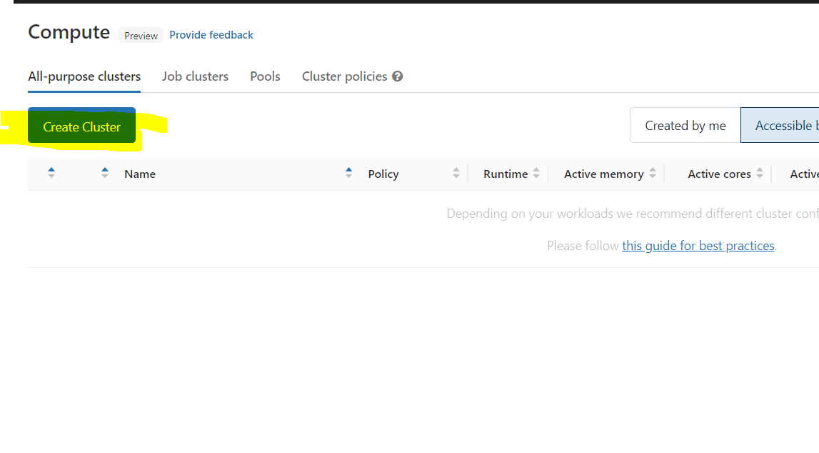

STEP 3:- FILL DETAILS OF THE CLUSTER AS GIVEN IN THE PICTURE LIKE CLUSTER NAME, CLUSTER MODE- WHICH WE HAD TO CHOOSE SINGLE NODE. THEN CHOOSE DATBRICK RUNTIME VERSION. AND SELECT AUTOPILOT AT 30 MIN. THEN CLICK ON CREATE CLUSTER.

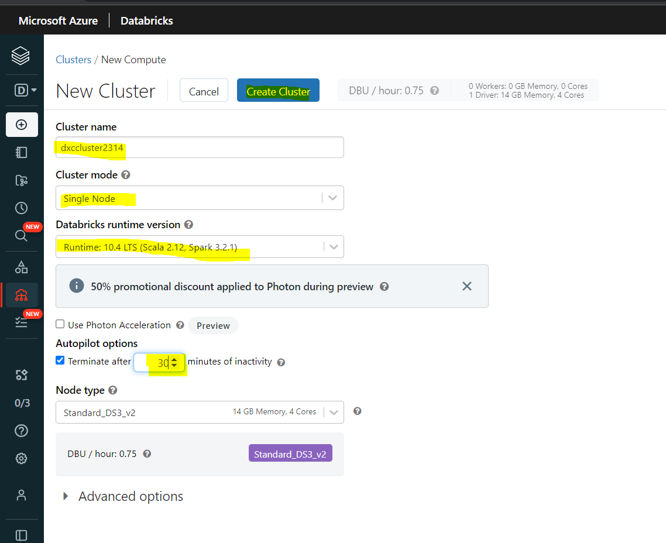

STEP 4:- IT WILL LOAD AFTER SOME TIME. AND THEN CLUSTER WILL BE CREATED.

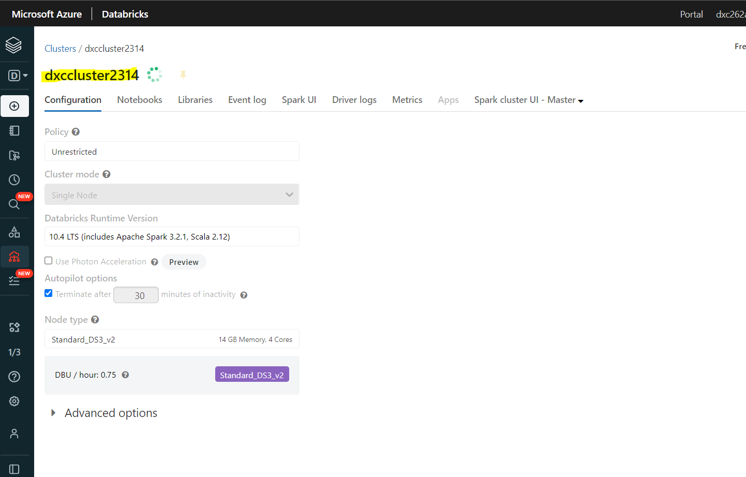

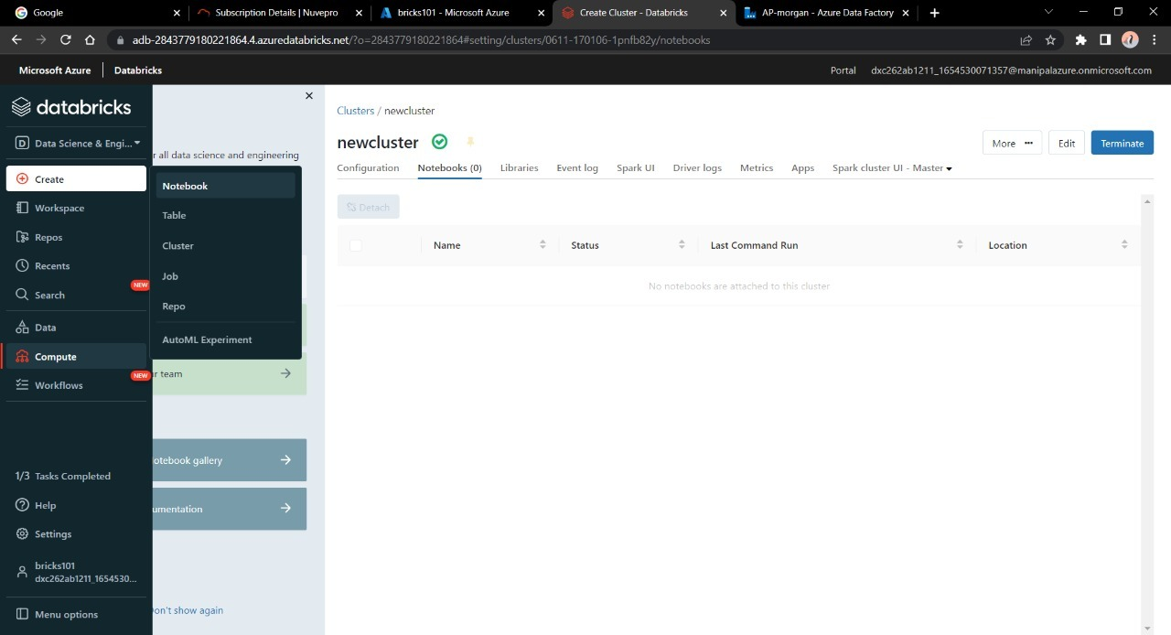

Practical Lab: **Add notebook in Databricks** and Implement the Business Logic.

STEPS TO CREATE NOTEBOOKS IN DATABRICKS:-

STEP 1:- AFTER CREATING CLICK ON LAUNCH WORKSPACE.



STEP 2:- CLICK ON WORKSPACE, THEN CLICK ON DROPDOWN MENU THEN CLICK ON CREATE AND SELECT NOTEBOOK.

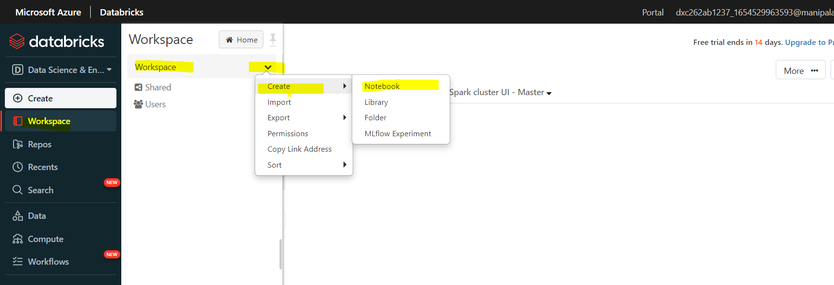

STEP 3:- IN CREATE NOTEBOOK GIVE NAME, DEFAULT LANGUAGE AND CLUSTER NAME THEN CLICK ON CREATE.

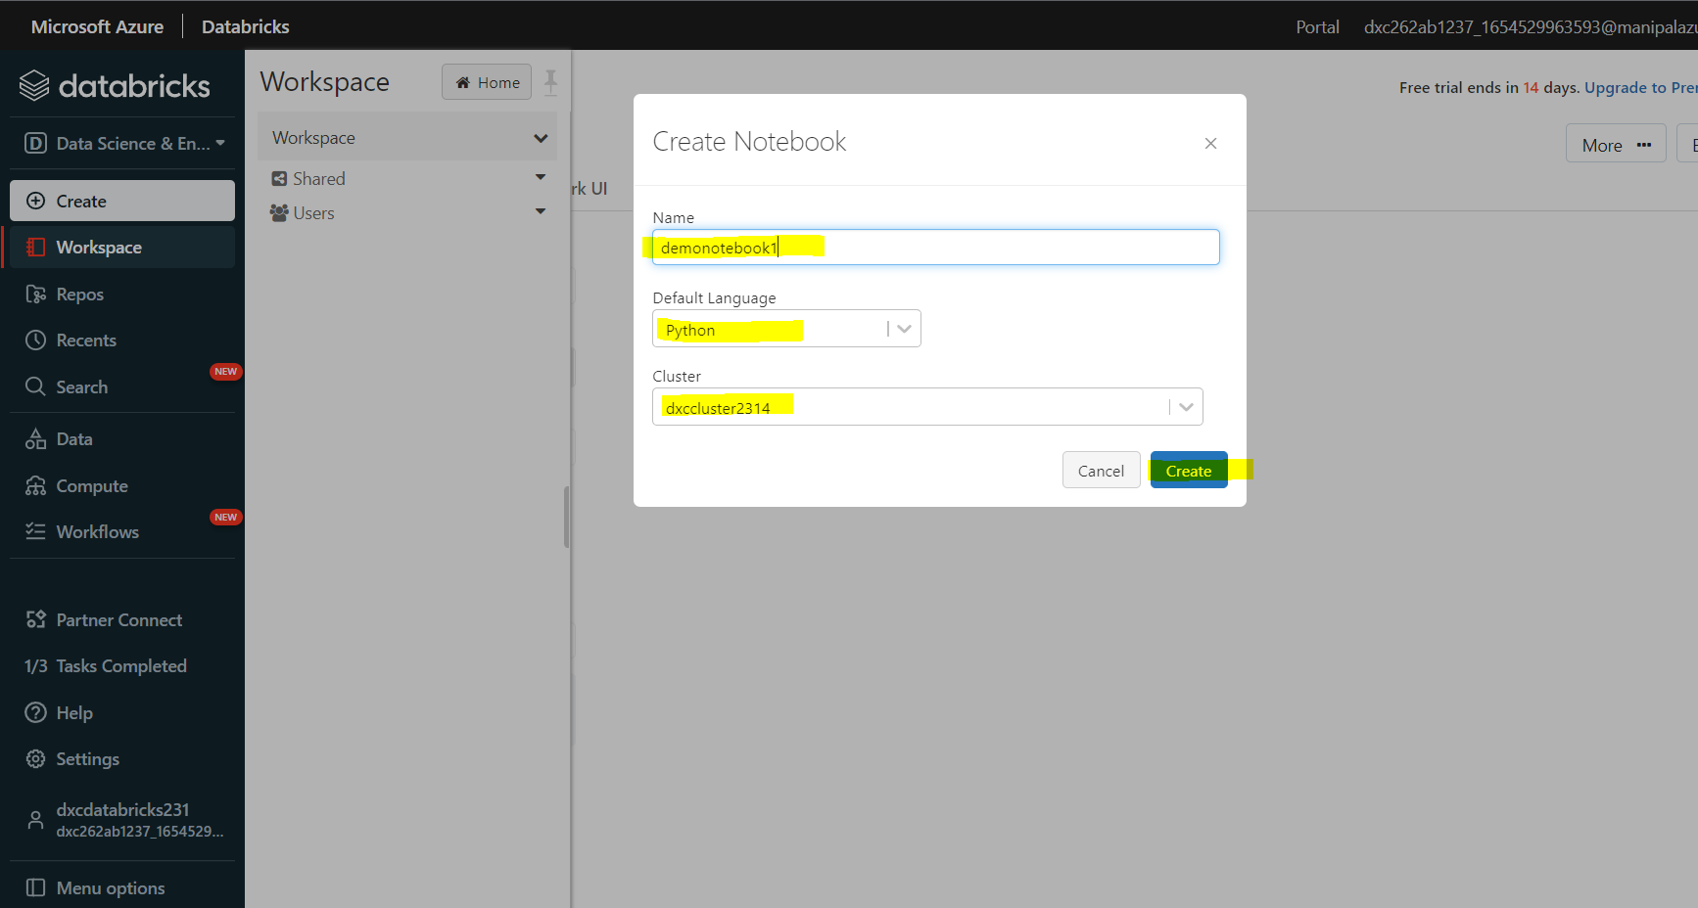

STEP 4:- THEN NOTEBOOK IS CREATED.

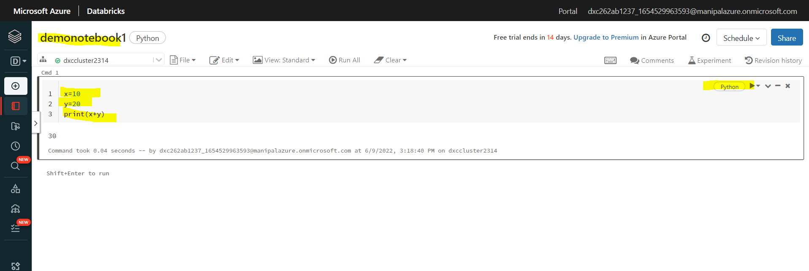

STEPS TO Implement the Business Logic AND INSERT DATA INTO THE DATABRICKS NOTEBOOK AND DISPLAY RESULTS:

STEP 5:- GO TO DATA, SELECT DATABASES THEN TABLES AND CLICK ON CREATE TABLE.

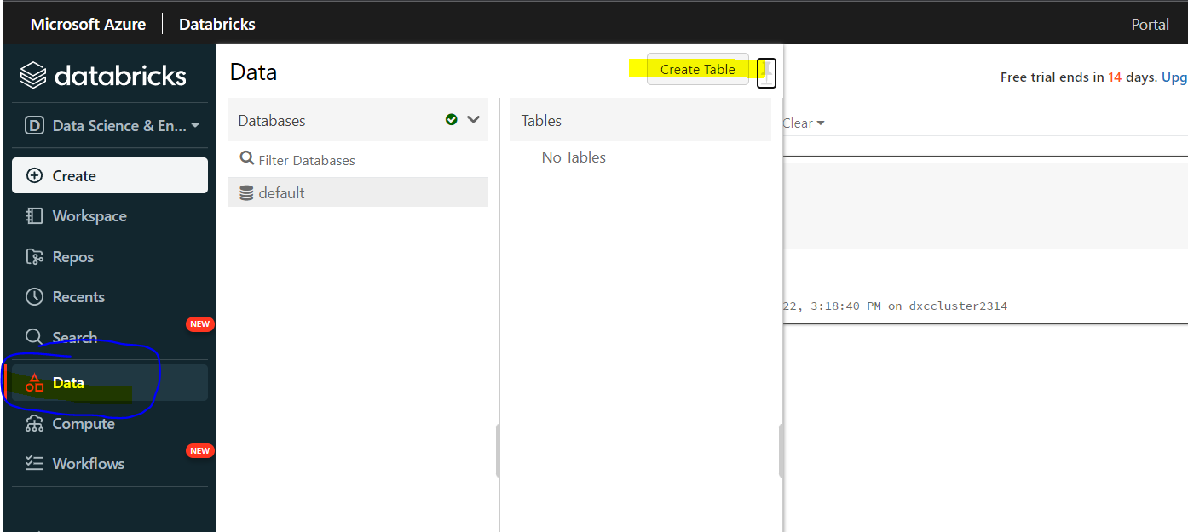

STEP 6:- IN UPLOAD FILES, SELECT FILES FROM THE DIRECTORY.

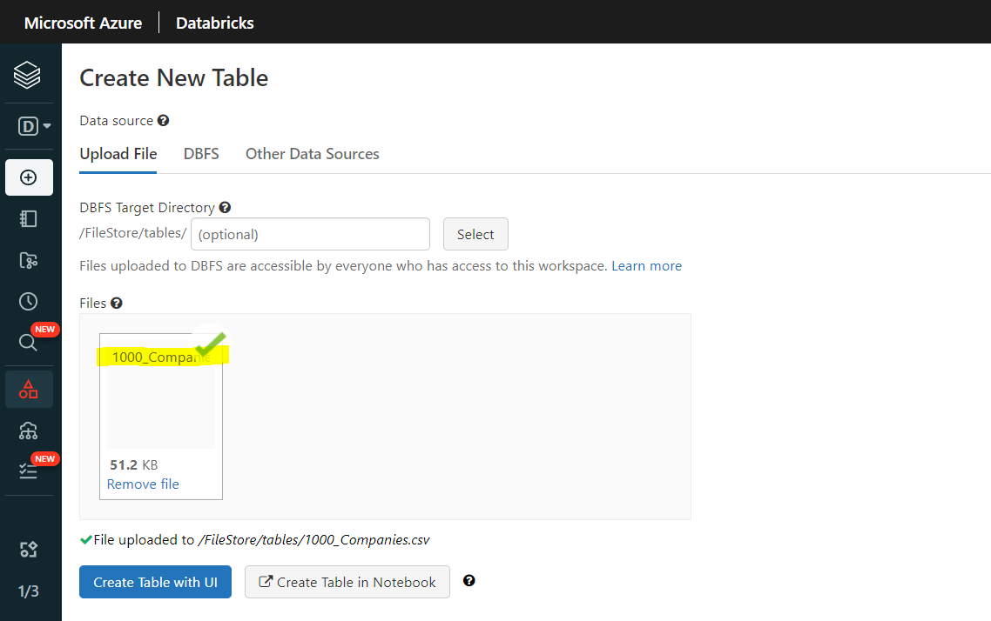

STEP 7:- CLICK ON CREATE TABLE IN NOTEBOOK.

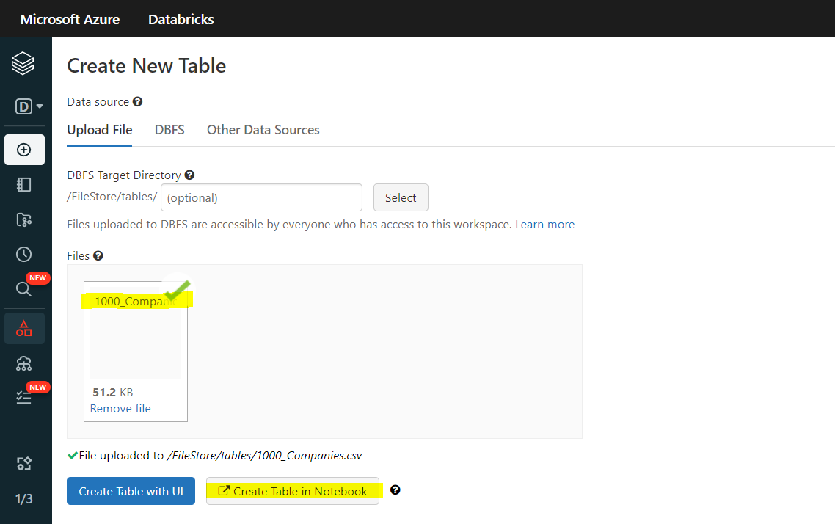

STEP 8:-YOU CAN SEE ALL THE DATA OF TABLE.

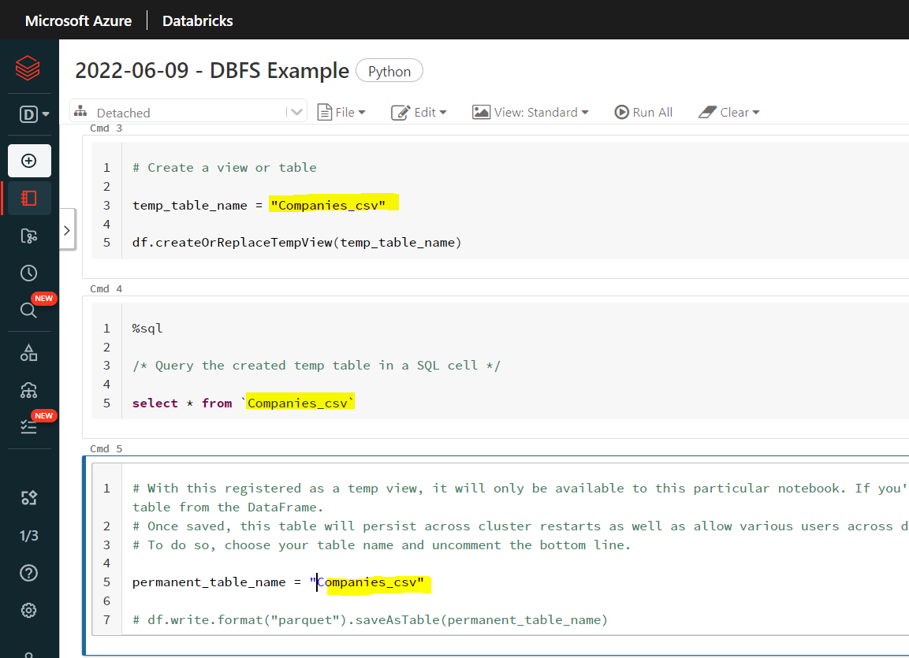

STEP 9:- CLICK ON DROP DOWN MENU AND SELECT THE CLUSTER.

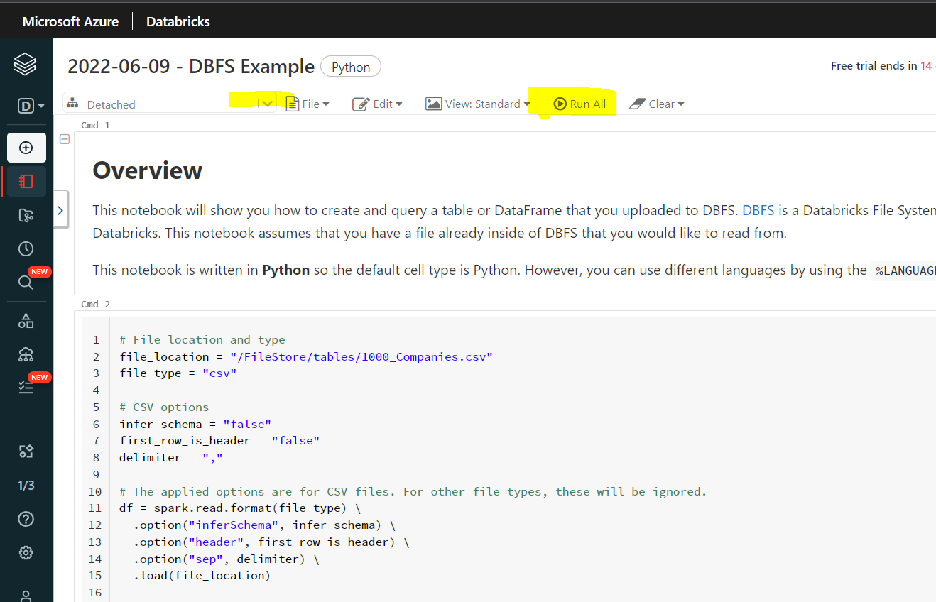

STEP 10:- AFTER SELECTING CLUSTER CLICK ON RUN ALL COMMAND.

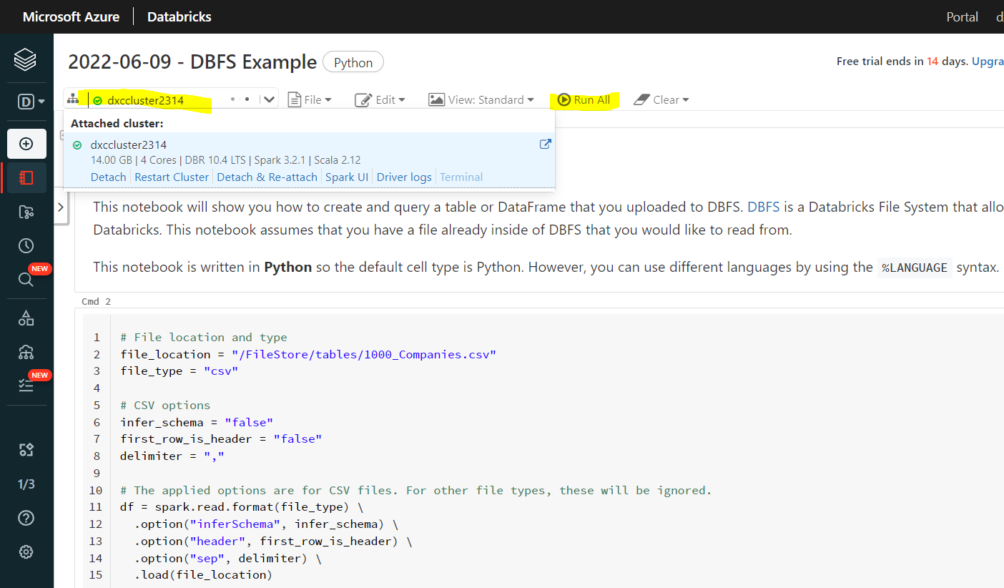

STEP 11:- HERE YOU CAN SEE THE DATA IN CHART FORMAT. CLICK ON PLOT OPTION.

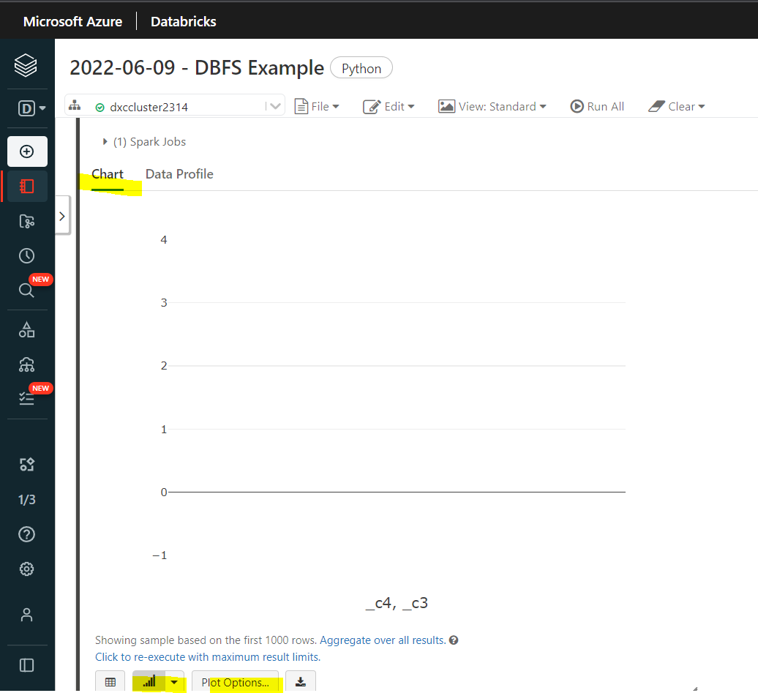

STEP 12:- HERE YOU CAN CUSTOMIZE THE PLOT.

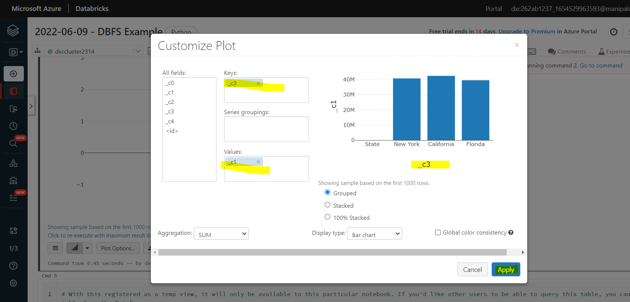

HERE IS ANOTHER METHOD

STEP 13:-IN CREATE NEW TABLE CLICK ON UPLOAD FILE AND UPLOAD THE FILE. AND THEN CLICK ON CREATE TABLE WITH UI. NOW CLICK ON PREVIEW TABLE.

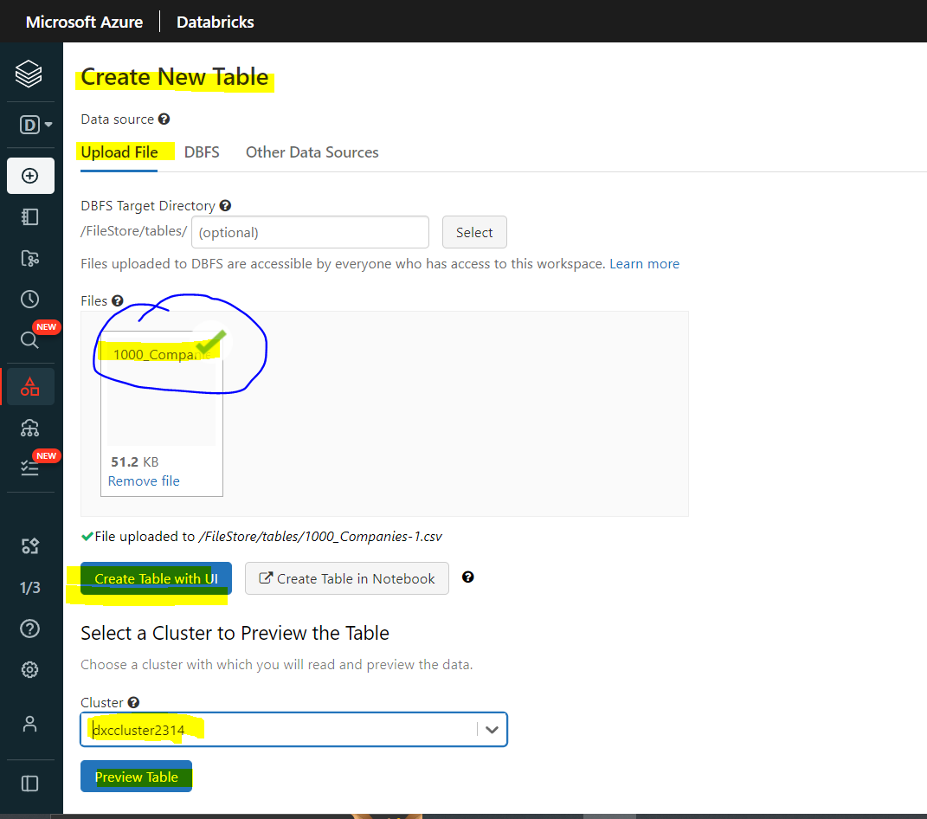

STEP 14:-TABLE IS CREATED.

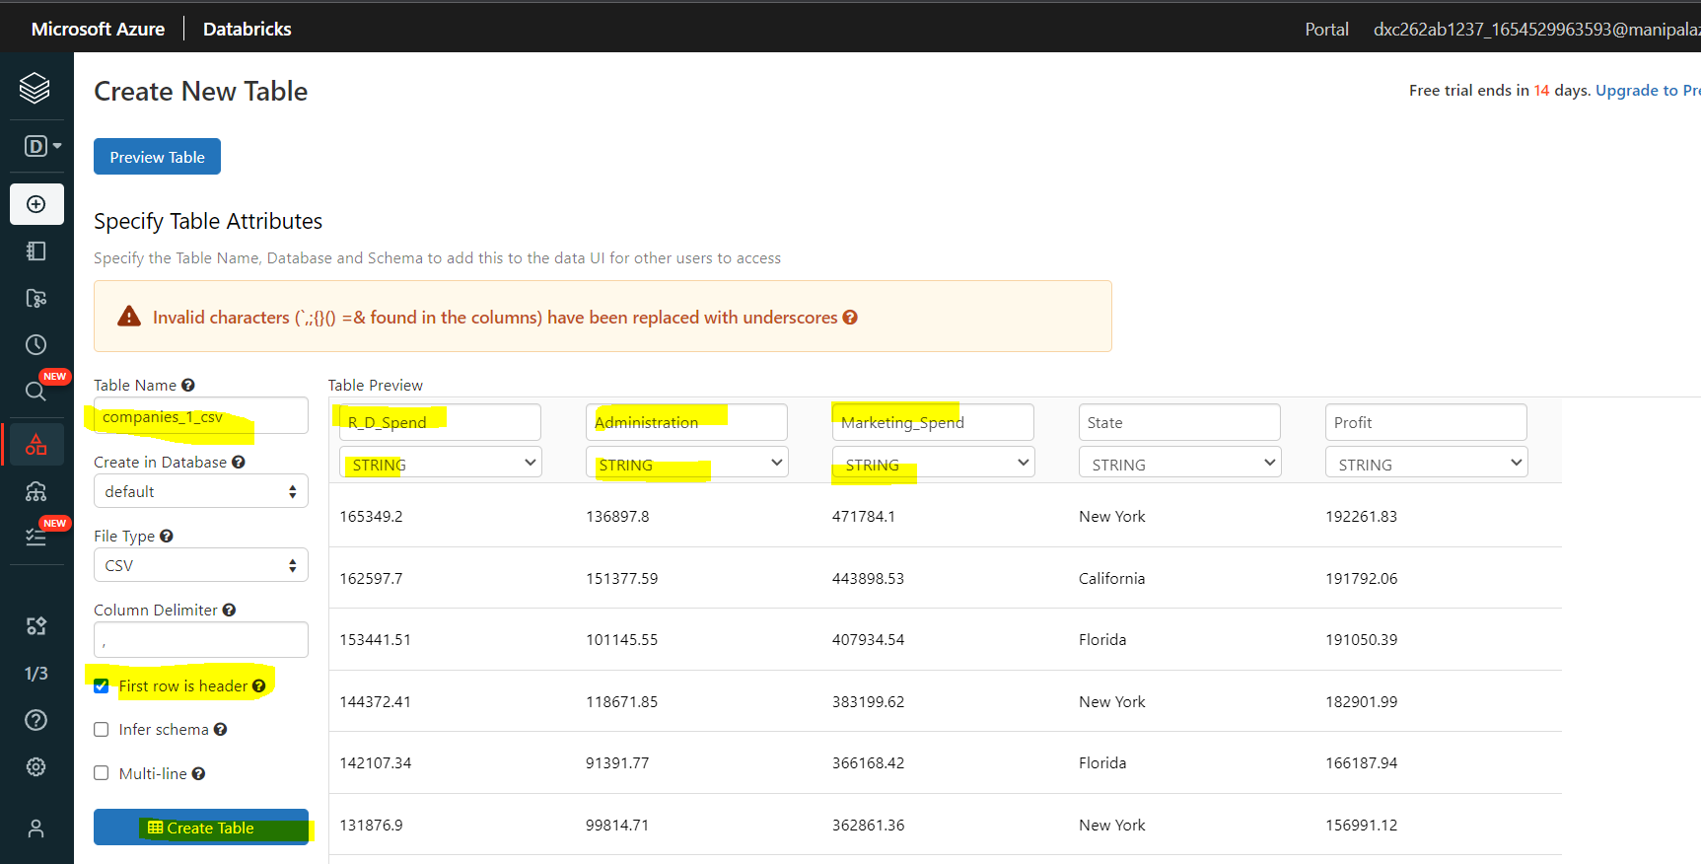

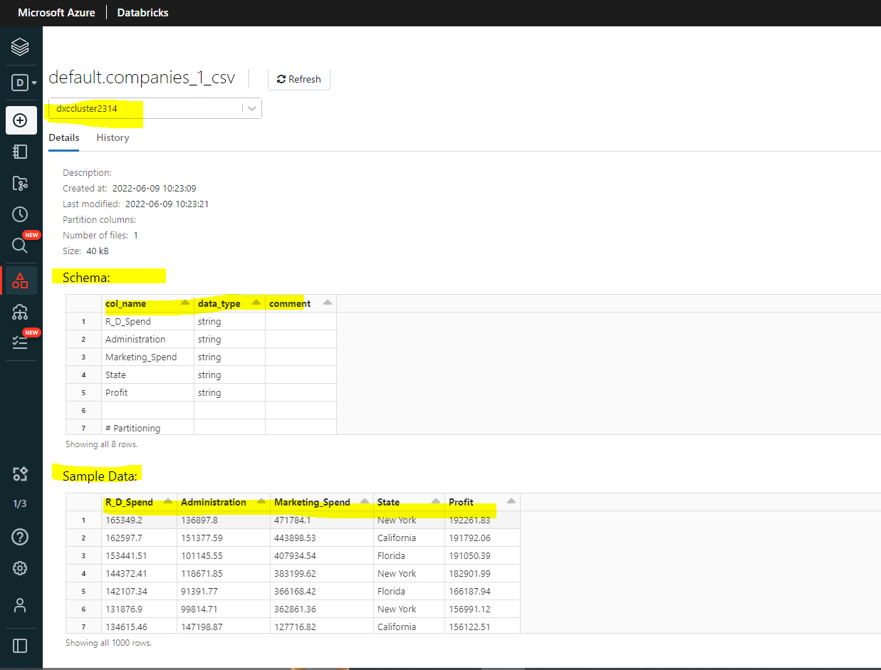

NOW OUR NOTEBOOK IS READY TO BE LINKED AND EXECUTED IN AZURE DATA FACTORY.

Practical Lab: **Azure Data Factory** for AP Morgan

STEPS TO CREATE AZURE DATA FACTORY FOR AP MORGAN.

STEP 1:- GO TO AZURE HOME PAGE AND SEARCH FOR DATA FACTORY.

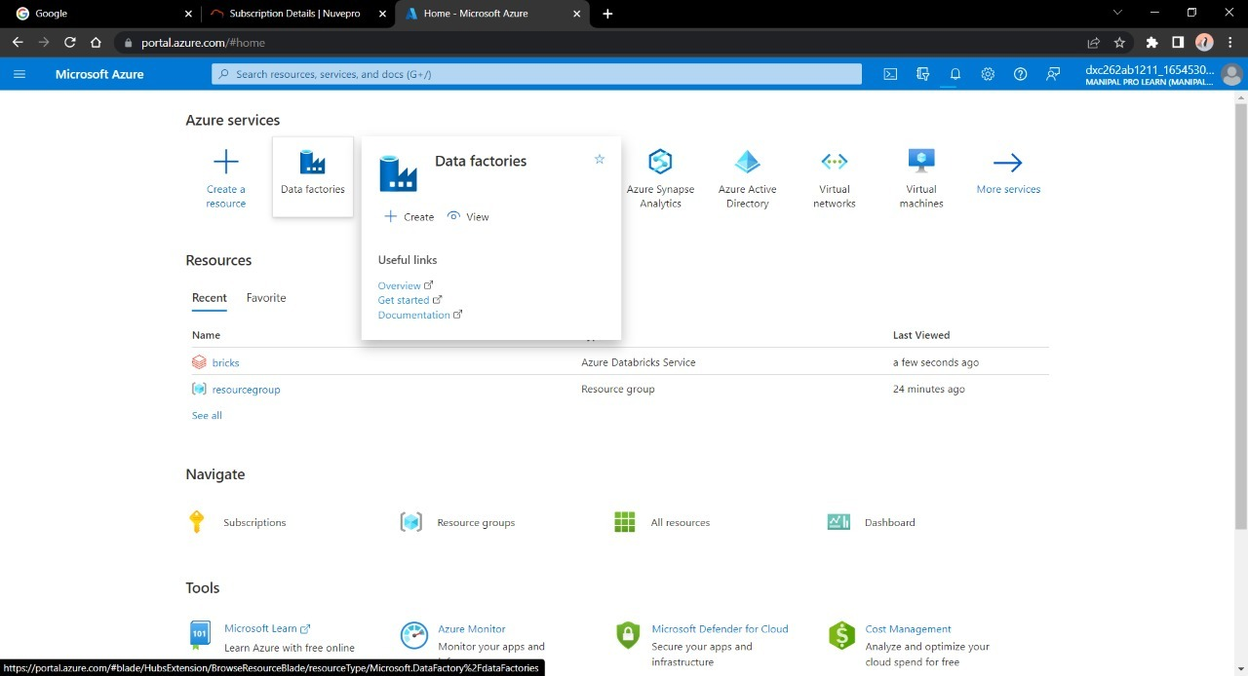

STEPS 2: CREATE A NEW ACCOUNT ON AZURE DATA FACTORY.FOR THAT CLICK ON CREATE.

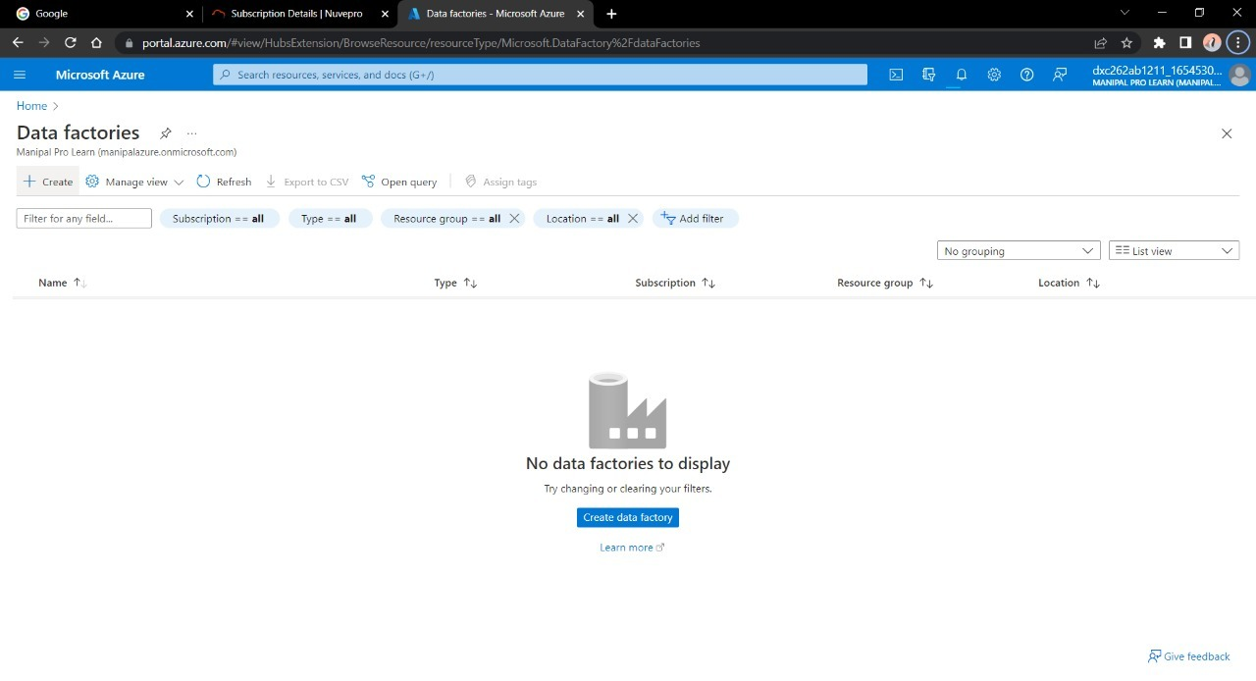

STEP 3: Enter the details for the factory account. And fill all the project details.

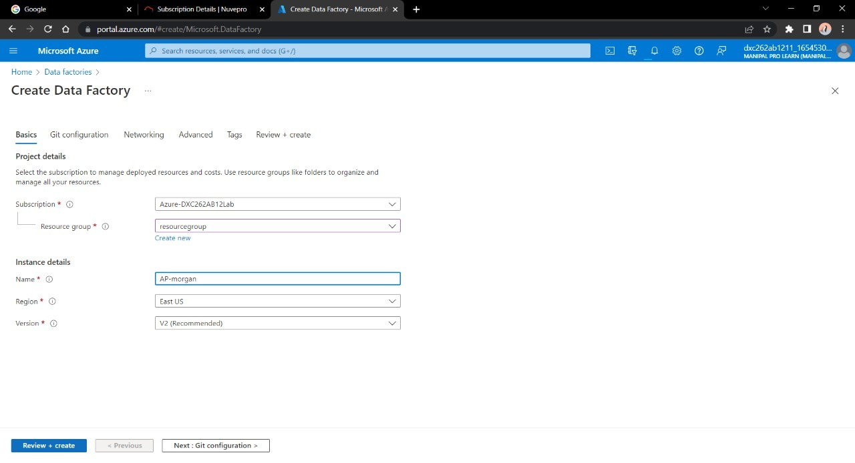

STEP 4: VALIDATE AND DEPLOY THE DATA FACTORY.AND VALIDATING IS COMPLETED CLICK ON CREATE.

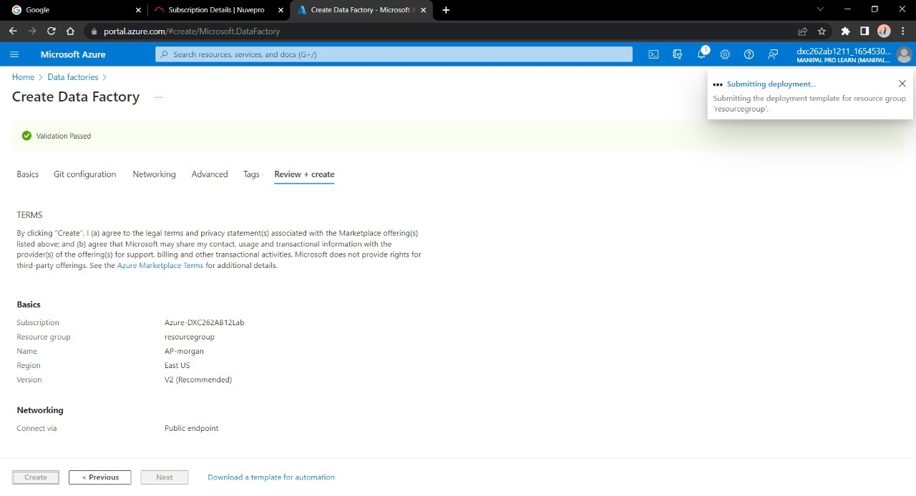

STEP 5: After the deployment is done, Navigate to “Go to resource”

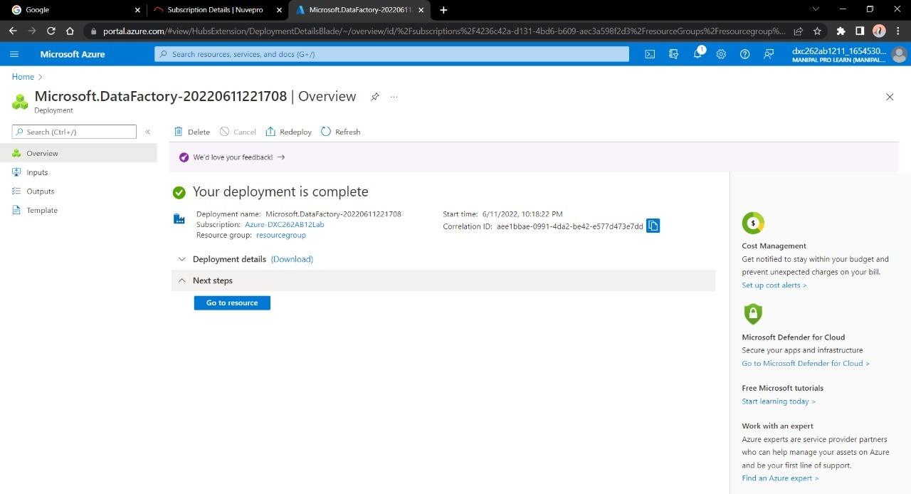

STEP 6: NOW OPEN THE DATA FACTORY STUDIO.

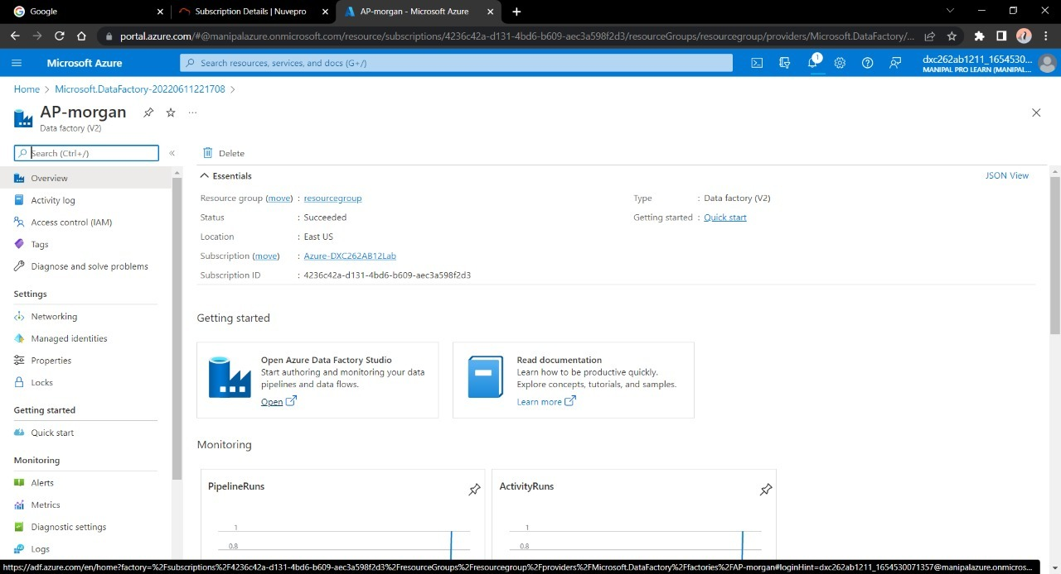

Practical Lab: **Create Azure Databricks** Linked Service in ADF.

WE NEED TO CREATE A PIPELINE THAT WILL CONNECT DATA BRICKS NOTEBOOK WITH DATA FACTORY.

STEP 1: CLICK ON THE ADD SIGN, GO TO PIPELINE AND SEECT PIPELINE.

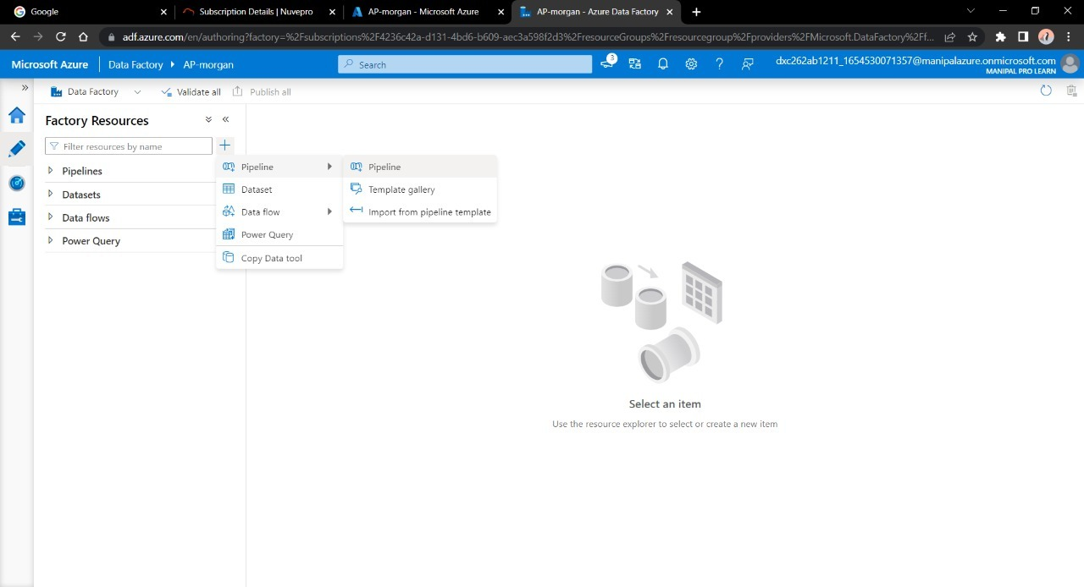

STEP 2: Create a new Pipeline and drag and drop the notebook tab from Azure Databricks dropdown into the pipeline workspace.

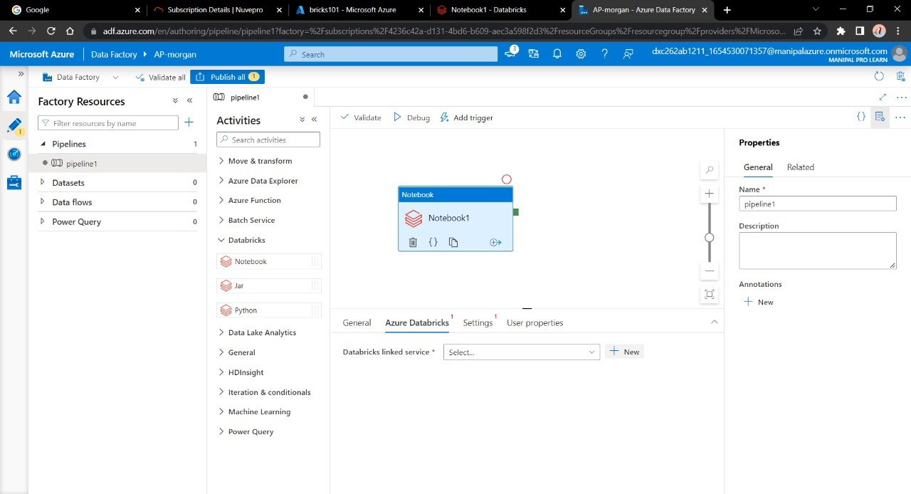

Step 3: Create a new Linked service for databricks.

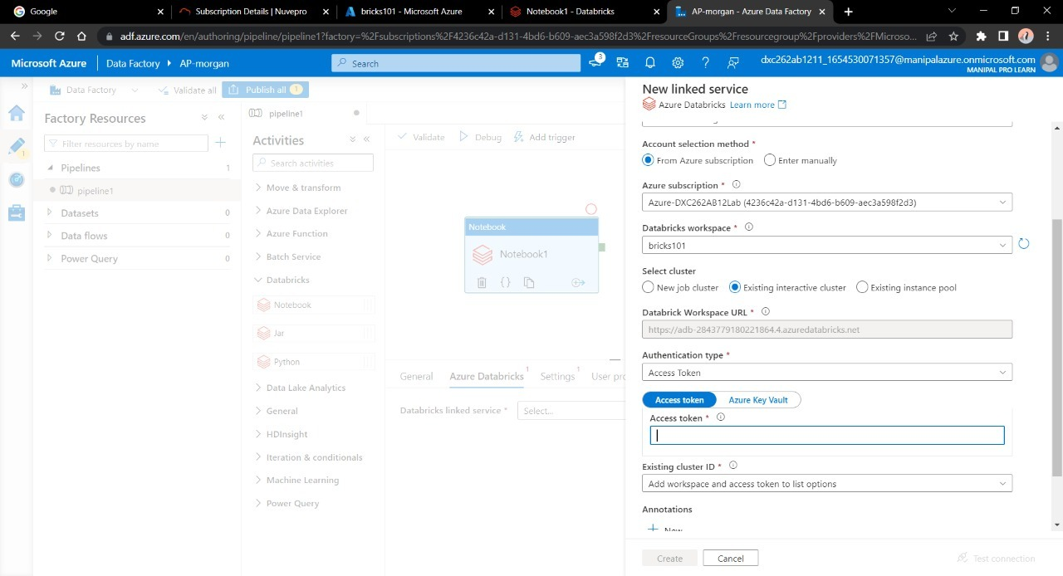

Step 4: Now, we need the access token of Data bricks account in order to access it. Navigate to Data bricks workspace and go to Users in settings.

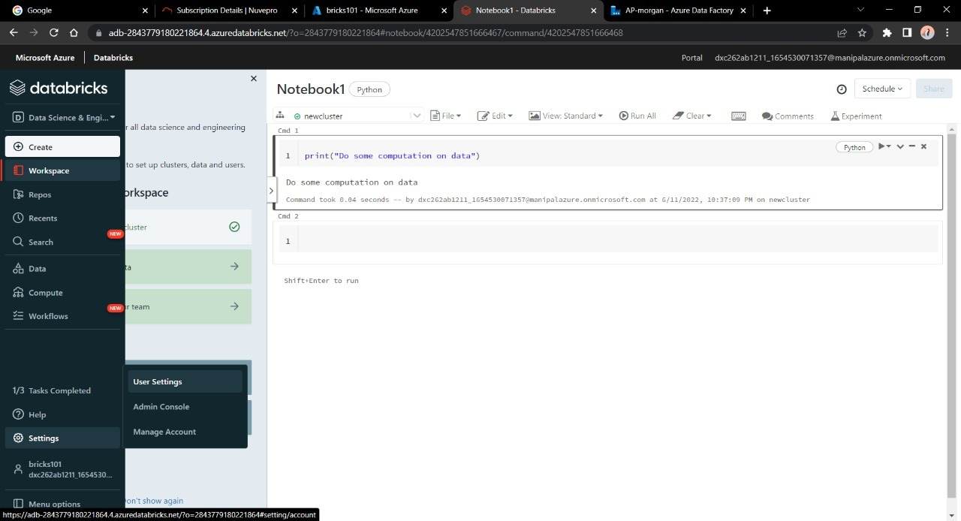

Step 5: Click on “Generate token” and mention a small quick description name for the token.

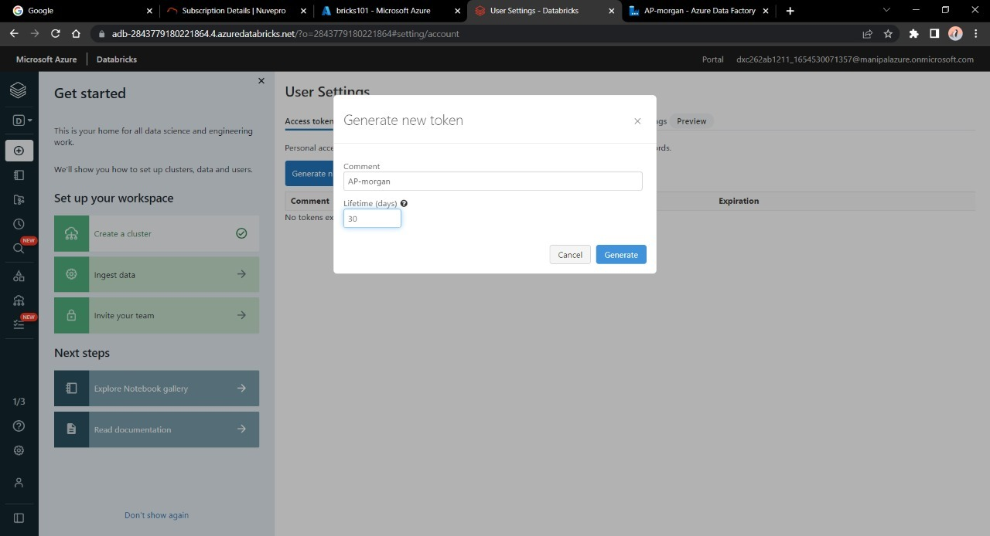

Step 6: After that a tab will open containing your access token, copy it and paste it in the azure factory data connection form.

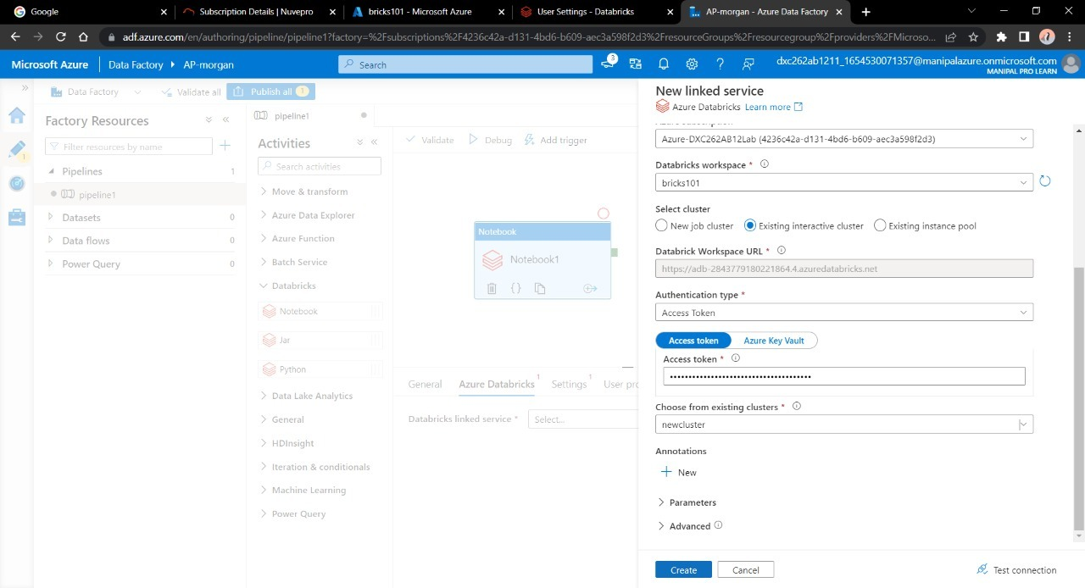

Step 7: Choose the right cluster and click on create.

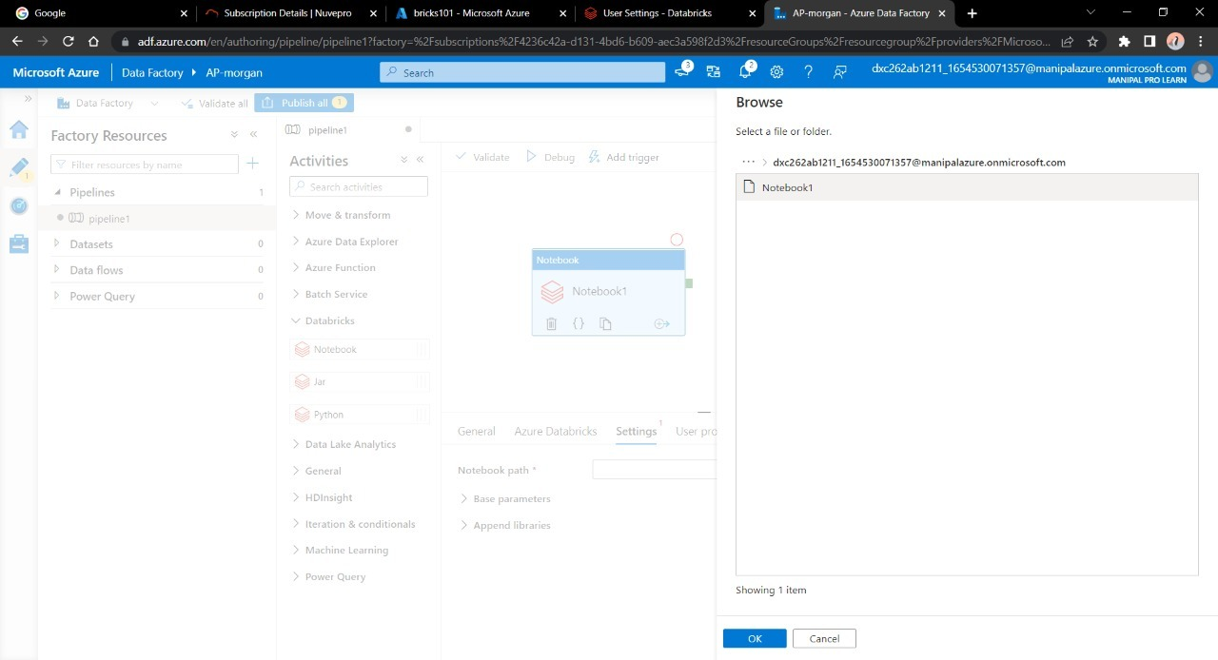

Now choose the notebook in the pipeline notebook tab setting in order to trigger it. Publish the pipeline in order to trigger it, after publication is done click on “Trigger now”.

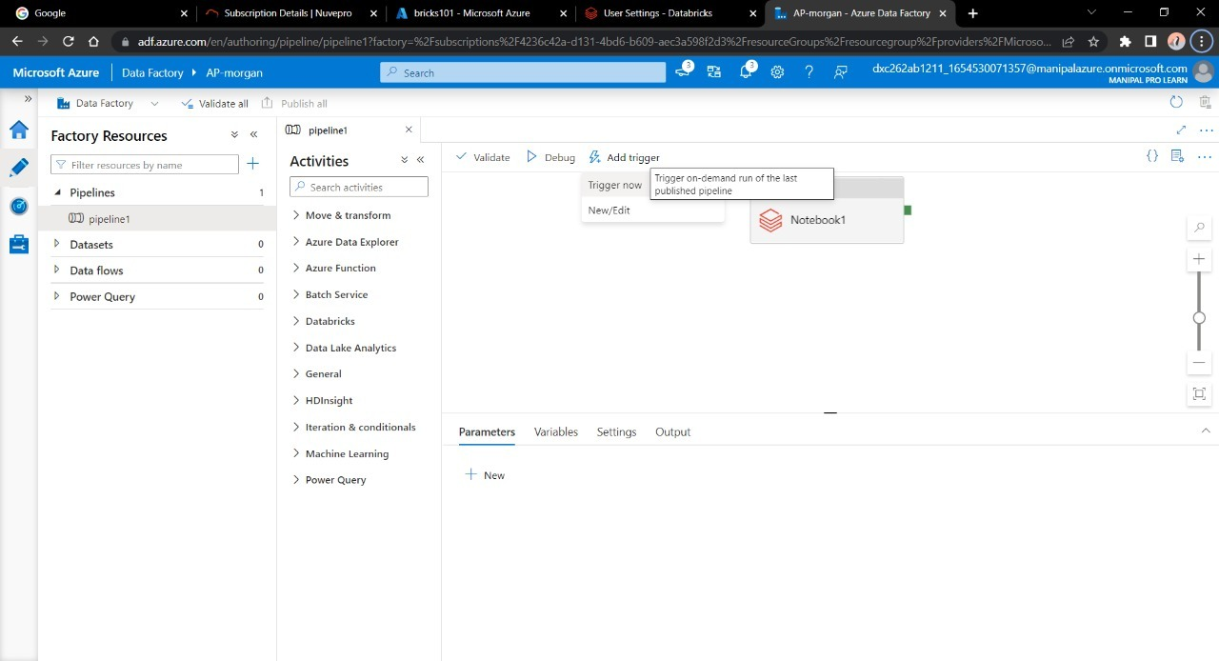

Step 8: Go to monitor window in order to check it’s execution.

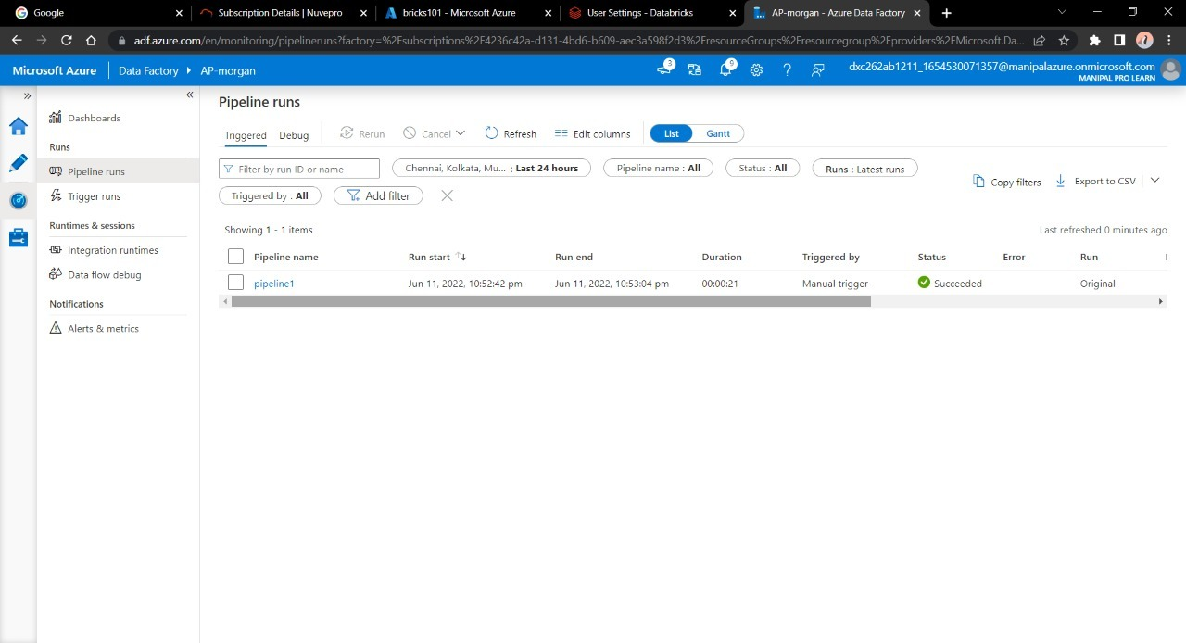

Here we can see we have successfully triggered a linked notebook of Data bricks from Data Factory.

**Result:** We had successfully linked and trigger Azure Databricks notebook using Data Factory.

**Conclusion:** Azure Data Factory linked with Azure Data bricks.